**A Project Report**

**on**

**Alzistant: Your Dementia Patient Assistant**

***Submitted by***

**Udyan Makhija 19csu329**

**Deepanshu Goel 19csu077**

**Pearl Arora 19csu208**

**Priya 19csu224**



**Department of CSE**

**The NorthCap University**

**Gurgaon**

**A Project Report**

**on**

**ALZISTANT: A DEMENTIA PATIENT ASSISTANT**

**of**

**Bachelor of Technology**

**in Computer Science Engineering and Information Technology**

**by**

**Udyan Makhija 19csu329**

**Deepanshu Goel 19csu077**

**Pearl Arora 19csu208**

**Priya 19csu224**

**Under supervision of**

**Mr. Sumit Kumar**

**(Assistant Professor)**



Department of CSE & IT

The Northcap University, Gurgaon

MAY 2023

**CERTIFICATE**

This is to certify that the Project Report entitled, “**Alzistant: A Dementia Patient Assistant**” submitted by “**Udyan, Deepanshu, Priya and Pearl**” to **The NorthCap University, Gurgaon, India**, is a record of bonafide Project work carried out by them under my supervision and guidance and is worthy of consideration for the award of the degree of **Bachelor of Technology** in **Computer Science Engineering** of the University.

Mr. Sumit Kumar

Assistant Professor

Date: ………………

**Acknowledgement**

To everyone who helped with the completion of this project, we would like to express our sincere gratitude and appreciation. Throughout this journey, their assistance, direction, and encouragement have been invaluable.

We want to start by expressing our gratitude to Mr. Sumit Kumar, the project supervisor, for his unwavering support and astute direction. The direction and focus of this project have been greatly influenced by their knowledge and suggestions.

We are grateful to NCU library for providing us with the necessary resources, facilities, and access to information. Their assistance was crucial in conducting the research and implementing the concepts.

We are indebted to our friends, family and work colleagues for their understanding, patience, and constant encouragement throughout this project. Their belief in me and their unwavering support have been a constant source of motivation.

In closing, we would like to express our gratitude to everyone who contributed—no matter how small or significant—to the successful completion of this project.

**Udyan Makhija (19csu329)**

**Deepanshu Goel (19csu077)**

**Priya (19csu224)**

**Pearl(19csu208)**

**ABSTRACT**

The project titled "Alzistant-The Dementia Assistant" as the name suggests, aims to develop an application with its Graphical User Interface (GUI) using React Native framework to create an efficient application. The application is designed to integrate some cutting-edge technologies for end-to-end development, including Natural Language Processing (NLP), RASA framework, Amazon Web Services, Voice, and Face Recognition using Deep Learning. One interface will be for the patient, and the other will be for the caregiver, in the application. Patients will be able to use the patient interface to recognize people, places, and things that are associated with them, set reminders, engage in cognitive games, and ask an AI assistant for assistance. While this is going on, the caretaker interface will enable them to intelligently assist the patient virtually, edit data, and easily add reminders. The overall goal of the project is to use artificial intelligence to provide a comprehensive solution for helping dementia patients and their caregivers. Dementia, a progressive illness that gradually impairs memory and other critical mental functions, affects millions of people worldwide, is one of the leading causes of disability and dependency among older people worldwide, and currently has no known cure. This is why the project was created. The most prevalent form of dementia is Alzheimer's disease, which can cause distressing behavioral issues and communication issues for both patients and caregivers. The application seeks to address these issues with workable solutions.

*Keywords: Alzistant, Dementia Assistant, Graphical User Interface (GUI), React Native framework, Natural Language Processing (NLP), RASA framework, Amazon Web Services, Voice Recognition, Face Recognition, Deep Learning, end-to-end development, cognitive ability, smart assistance, Artificial Intelligence, progressive disease, Alzheimer’s disease*

**TABLE OF CONTENTS**

Certificate……………………………………………………….…………………......iii Acknowledgements……………………………………………………………………iv Abstract……………………………………………..………………….........................v

List of Tables...………………………………..……….………………........................viii

List of Figures….……………..………………………….…………………………….ix

List of Symbols and Abbreviations…………………………………………………….xi

1. Introduction……………………………………….…………….…...................01
   1. Background……………………………………………………….....................02
   2. Implementation Idea…………………………………………...........................02

1. Literature Review………………………………………….…………………..03
2. Problem Definition and Requirement Analysis………………..………............06
   1. Problem Statement…………………………………………………………06
   2. Study on Existing Solutions………………………………………………..06

3.3 Comparison with Existing Software Solutions…………………………….06

3.4 Gap Analysis…………………………………………………………….....10

3.5 Feasibility Study…………………………………………………….…......11

3.5.1. Technical Feasibility………………………………………….…......11

3.5.2. Operational Feasibility……………………………………….….......12

3.5.3. Economic Feasibility…………………………………………....…...12

4. Design and Implementation…………………………………...……………..….…..13

4.1 Objective……………………………………………………..………………...13

4.2 Tools/Platforms Used……………………………………..……………....……13

4.3 Detailed Explanation of Tools/Platforms Used………..…………………..…...14

4.3.1 AWS….………………………………………………………………..…14

4.3.2 RASA……...…………………………………………………..…………17

4.3.3 REACT NATIVE………………………………………………………...18

4.3.4 NODE JS…………………………………………………………………19

4.3.5 OPEN AI’s GPT3.5 TURBO API…………………………………….….20

4.3.6 VS CODE………………………………………………………………...21

4.3.7 WEB STORM……………………………………………………………21

4.3.8 Twilio…………………………………………………………….………22

4.4 Design Methodology: Agile Methodology………………………………..…….23

5. Testing and Deployment………………………..……………………………………24

5.1 Face Recognition…………………………………………………………….....24

5.2 Cognitive Games………………………………………………………..………25

5.3 Virtual Assistant (Chat GPT BASED Chatbot) ...................................................26

5.4 Backend: ...............................................................................................................28

5.5 Alzistant Web App (Beta) - Frontend……………………………..……….……34

5.6 Alzistant Mobile App (Frontend).......................................................................39

5.7 Conclusion……………………………………………………………….……45

6. Analysis and Result………………………………………………….…………..….45

6.1 Analysis………………………………………………………………………..46

6.2 Results……….…………………………………………………........................47

7. Conclusion and Future Enhancement………………….…………….........................48

8.References……………………………………………….………………………..….49

9. List of Appendices ……………………………………….……………………........50

**LIST OF TABLES**

3.2 Existing Solutions

3.2 Comparison Between Existing and Offered Solutions

3.4 Gap Analysis Table 1

3.4 Gap Analysis Table 2

**LIST OF FIGURES**

3.11 Feasibility Study and Types

3.2 Existing Solutions-Google Maps, Location Sharing

3.2. Existing Solutions- Todoist, Task Reminder App

3.2. Existing Solutions- Lumosity-Cognitive Games

3.2. Existing Solutions- Alexa-Voice Assistant

3.2. Existing Solutions- Telehealth

3.2 Existing Solutions- Health Metrics Monitoring

4.2. Tools/Platforms Used

4.3.2 Rasa Architecture

4.3.5 An example API response

4.4 A Visual Representation of Agile Methodology

5.1.1 Steps for Face Recognition Model

5.1.3 Working chatbot Backend Snippet

5.1.3 Working chatbot Backend Snippet

5.1.3 Message Alert from Patient

5.1.4 Flow of Application

5.1.4 Face recognition Backend Processing

5.1.4 Face recognition Backend Process

5.1.4 Webapp Frontend - LOGIN

5.1.4 Webapp Frontend - Reminder, Gallery, Chatbot

5.1.4 Webapp Frontend - Reminder Setup

5.1.4 Webapp Frontend - Face Recognition

5.1.5 Pill Reminder Working in App

5.1.5 Photo Gallery in App

5.1.5 Relatives List for Emergency Contact

5.1.5 Chatbot UI in App

5.1.5 Login Pages

**LIST OF SYMBOLS AND ABBREVIATIONS**

AWS Amazon Web Services

DFD Data Flow Diagram

NLP Natural Language Processing

GUI Graphic user interface

AI Artificial Intelligence

RASA Recurrent Attentive Simultaneous model and Actor-Critic algorithm

**CHAPTER 1**

**INTRODUCTION**

The rising cases of dementia have underscored the urgent need for a dedicated platform to support individuals afflicted by this condition. While there is currently no cure for dementia, the medications available primarily aim to alleviate symptoms and promote a sense of calm. However, our project seeks to go beyond symptom management and focus on enhancing the lives of dementia patients and their families.

The objective of our app is to provide a user-friendly and comprehensive solution that eases the challenges faced by individuals living with dementia. We recognize that the impact of this condition extends beyond the patients themselves, significantly affecting their families as well. As patients progressively become more reliant on their families for support and care, it is crucial to extend assistance to both the patients and their loved ones.

Considering that approximately one million individuals suffer from dementia, it is essential to acknowledge that the true scope of those affected is even more significant. The ripple effects of this disease reach at least two million people, encompassing the patient's immediate family members and their support network.

Through our app, we aim to address these pressing needs by providing a specialized platform designed to enhance the quality of life for individuals with dementia. By utilizing innovative technologies and a user-centric approach, we aspire to make daily tasks more manageable, foster meaningful connections, and empower both patients and their families to navigate the challenges associated with this disease.

In summary, our project endeavors to develop an app that goes beyond the limitations of current medications by offering practical support and easing the burdens faced by individuals living with dementia. By prioritizing user convenience and considering the wider impact on their families, we aim to create a valuable tool that improves the well-being of dementia patients and provides much-needed support to their loved ones.

* 1. **Background:**

Dementia is a degenerative disorder that gradually deteriorates memory and other vital cognitive functions. Its effects extend to areas such as orientation, comprehension, calculation, language, learning capacity, and judgment. Although consciousness remains unimpaired, Alzheimer's disease, the most prevalent form of dementia, has caused over 50 million people worldwide to suffer from the condition. Experts predict a 50% increase in this number in the next few decades. Dementia currently ranks as the seventh leading cause of death worldwide and is a primary cause of disability and dependency in older individuals. This condition stems from various diseases and injuries affecting the brain, including Alzheimer’s and stroke. Dementia not only impacts the physical and psychological aspects of those living with the disease but also affects their families, caregivers, and society. Stigma and lack of awareness often hinder diagnosis and treatment. Providing care for a loved one with dementia is a significant challenge, as it is accompanied by behavioral issues, daily task difficulties, mood swings and altered personality traits. Our application aims to provide feasible solutions to these issues by assisting dementia patients and their caregivers. As always being available for assistance is not always feasible, our application serves as a supportive and reliable tool to aid those affected by dementia.

1.2  **Implementation:**

Our application will feature two distinct interfaces, catering to both the patient and the caretaker. Each interface will provide specialized functionalities to address the unique needs and challenges faced by these respective user roles.

For the patient interface, our aim is to develop a platform that offers comprehensive support and assistance. Key features of this interface will include:

* **Face recognition:** The app will enable users to quickly identify and connect with their loved ones by utilizing cutting-edge face recognition technology**.** The patient's general well-being is improved by this feature, which fosters a sense of familiarity and emotional connection.
* **Pill reminder system:** We'll put in place a dependable, user-friendly pill reminder system**.** Patients can set reminders for their medication schedules, ensuring that they take their medications on schedule and correctly. The purpose of this function is to encourage medication adherence and effective health management.
* **Health bot:** Using AI technology, our app will offer a health bot that serves as a patient's virtual assistant.The health bot will provide patients with personalized health information, respond to questions, offer advice on medication use, and generally support and assist them.
* **Cognitive games:** The app will offer a selection of fun games that are designed to enhance recall, mental agility, and all-around cognitive function**.** You'll have fun playing these games while improving your wellbeing and mental acuity.

Innovative technologies like Virtual Reality (VR), Artificial Intelligence (AI), Cloud Computing, and Natural Language Processing (NLP) will be used to create all these patient-focused features. The advantages of these cutting-edge technologies will be delivered directly to the patients thanks to this integration, which will guarantee a seamless and engaging user experience.

We will offer a unique interface created especially for caregivers in addition to the patient interface. They will have access to the crucial data and resources they need to support their caregiving duties through this interface. Key functionalities of the caretaker interface will include:

* **Location tracking for the patient:** Attendants will have access to the patient's current location.This feature gives caregivers peace of mind and makes it possible to watch over patients' movements and guarantee their security.
* **Medication management:** Caretakers can access and manage the patient's medication information, including dosage schedules, reminders, and prescription details. This functionality helps caregivers stay organized and ensures medication adherence for the patient.
* **Task reminder management:** Caretakers can add and manage task reminders on behalf of the patient. This feature enables caregivers to assist in organizing the patient's daily routine and ensure important tasks are completed in a timely manner.
* **Access to bot conversations:** Caretakers will have the ability to view and review the patient's conversations with the health bot. This provides valuable insights into the patient's concerns, queries, and overall well-being, allowing caregivers to offer appropriate support and guidance.

To give patients the best care and support, the caregiver interface works in conjunction with the patient interface. Both interfaces will be seamlessly connected, facilitating efficient communication and coordination between the patient and the caretaker.

Our application aims to create a comprehensive and supportive platform that uses emerging technologies to enhance the lives of people with dementia by combining these patient- and caregiver-centric features.

**CHAPTER 2**

**LITERATURE REVIEW**

The rising prevalence of dementia has led to increased research and development efforts in the field of dementia care. This literature review aims to provide an overview of the existing research and initiatives related to supporting individuals with dementia and their caregivers, as well as the role of technology in improving their quality of life.

**1. Impact of Dementia on Individuals and Caregivers:**

Numerous studies have highlighted the profound impact of dementia on individuals and their families. The physical, cognitive, and emotional symptoms associated with dementia often result in decreased independence, increased dependency on caregivers, and a decline in overall well-being. Dementia also places a significant burden on caregivers, leading to increased stress, caregiver burnout, and negative impacts on their own mental and physical health. Therefore, interventions and support systems that address the needs of both individuals with dementia and their caregivers are essential.

**2. Current Approaches to Dementia Care:**

Current approaches to dementia care primarily focus on symptom management and medication-based interventions. While medications can help alleviate some symptoms, they do not address the holistic needs of individuals with dementia. Non-pharmacological interventions, such as cognitive stimulation therapy and person-centered care, have shown promise in improving cognitive function and overall well-being. However, there is a need for innovative solutions that can provide comprehensive support to individuals with dementia and their caregivers.

**3. Role of Technology in Dementia Care:**

Technology has the potential to revolutionize dementia care by offering novel solutions to the challenges faced by individuals with dementia and their caregivers. Previous research has explored the use of various technologies, including assistive technologies, telehealth, virtual reality, and artificial intelligence, in dementia care. These technologies have shown promising results in improving cognitive function, providing social engagement, enhancing safety, and supporting medication management. However, there is a need for user-friendly and comprehensive platforms that integrate multiple technologies to address the complex needs of individuals with dementia and their caregivers.

**4. User-Centric Approach to Dementia Care:**

A user-centric approach is crucial in developing effective interventions for individuals with dementia. Tailoring interventions to the specific needs, preferences, and abilities of individuals with dementia can enhance engagement and maximize the benefits of the interventions. User-friendly interfaces, intuitive design, and personalized features are essential components of an effective dementia care app. By considering the perspectives of both individuals with dementia and their caregivers, a user-centric approach ensures that the app provides practical support, fosters meaningful connections, and improves the overall well-being of its users.

**5. Limitations and Future Directions:**

While technology-based interventions show promise in dementia care, there are still limitations and challenges to be addressed. These include accessibility issues, privacy concerns, and the need for ongoing user support and training. Future research should focus on evaluating the long-term effectiveness and scalability of technology-based interventions. Additionally, collaborations between researchers, healthcare professionals, and technology developers are crucial for the successful implementation and adoption of these interventions in real-world settings.

**Conclusion:**

The literature reviewed highlights the urgent need for comprehensive support for individuals with dementia and their caregivers. Technology-based interventions, such as the proposed app, have the potential to address the limitations of current approaches to dementia care. By providing user-friendly interfaces, integrating innovative technologies, and adopting a user-centric approach, the app aims to improve the quality of life for individuals with dementia and provide much-needed support to

**CHAPTER 3**

**PROBLEM DEFINITION AND REQUIREMENT ANALYSIS**

**3.1 Problem Statement**

The most prevalent form of dementia, Alzheimer's disease, affects about 50 million people worldwide. This number is projected to increase by 50% over the next few decades.

There aren't many effective and user-friendly technological aids for dementia patients and their caregivers. Alzheimer's disease is a crippling condition that impairs memory and cognitive abilities, making it difficult for patients to carry out daily tasks and communicate with their loved ones. Caregivers struggle to manage their loved ones' care while juggling their personal and professional obligations. It is difficult for patients and caregivers to use the current market solutions effectively because they are either user-unfriendly or have limited functionalities. To meet the needs of dementia patients and their caregivers, an AI-based assistant that is intuitive, personalized, and capable of doing so must be created. The Alzistant project seeks to close this gap and offer a complete solution that takes advantage of the most recent technological advancements to simplify life for patients and caregivers.

**3.2 Study on Existing Solutions**

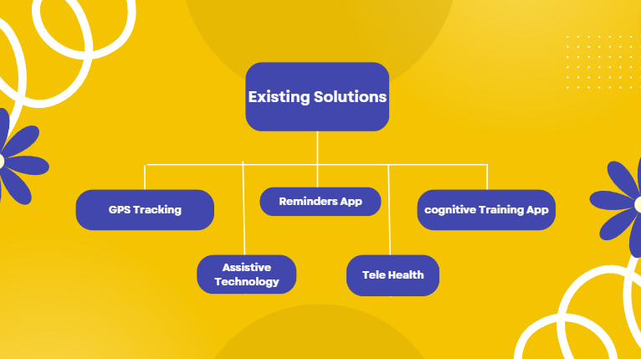

*Figure 3.2.1: Current Solutions*

Although the main goal of our project is to create an AI-based assistant designed specifically for dementia patients, it is important to recognize that there are already technological advancements that may be able to help these people. However, because they are spread out across several platforms and not specifically targeted at dementia patients, these solutions lack a centralized and all-inclusive approach.

* **GPS Tracking Through Google Maps**
* 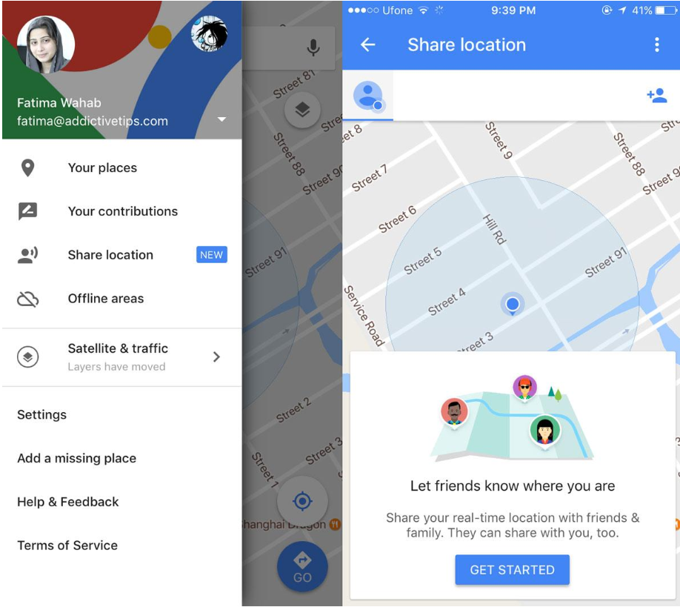

*FIG 3.2.2 Existing Solutions-Google Maps, Location Sharing*

GPS tracking technology can be useful for dementia patients who tend to wander and get lost. GPS-enabled devices such as watches or bracelets can be worn by patients and allow caretakers to track their location in real-time.

* **Reminder Apps like Todoist**
* 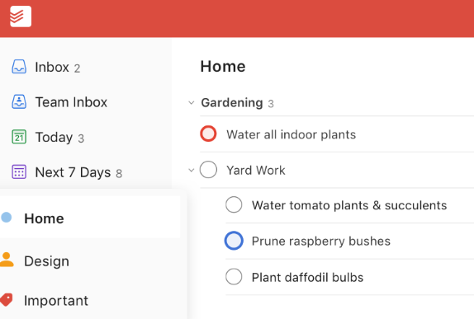

*FIG 3.2.3. Existing Solutions- Todoist, Task Reminder App*

There are many reminder apps available that can be used by dementia patients to help them remember important tasks such as taking medication, attending appointments, or completing daily tasks.

* **Cognitive Training Apps like Lumosity:**
* 

*FIG 3.2.4. Existing Solutions- Todoist, Task Reminder App*

There are also many cognitive training apps available that are designed to help improve memory, attention, and other cognitive skills. These apps use various exercises and games to challenge the brain and improve cognitive function.

* **Assistive Technology Like Alexa:**
* 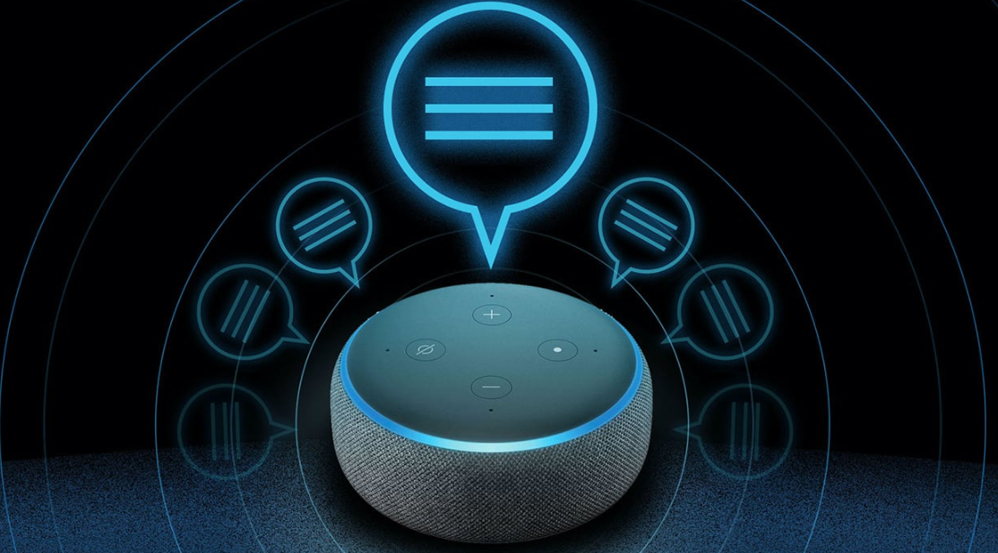

*FIG 3.2.5. Existing Solutions- Todoist, Task Reminder App*

There are many assistive technologies available that can help dementia patients with everyday tasks. These technologies include things like automated lighting, voice-activated assistants and smart home devices that can be controlled through voice commands.

* **Online Doctor’s Assistance like Telehealth:**
* 

*FIG 3.2.6. Existing Solutions- Telehealth*

Telehealth technology can be used to provide remote care and support to dementia patients. This technology can include video conferencing with healthcare professionals, remote monitoring of vital signs, and online support groups for patients and their families.

* **Wearable Devices:**
* 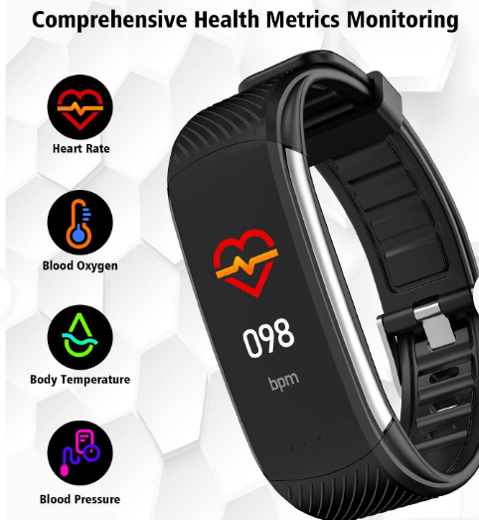

*FIG 3.2.7. Existing Solutions- Health Metrics Monitoring*

Devices such as smartwatches can be used to monitor vital signs and detect changes in health. This technology can be particularly useful for dementia patients who may have difficulty communicating their symptoms to caregivers or healthcare professionals.

**3.3 Comparison with Existing Software Solutions**

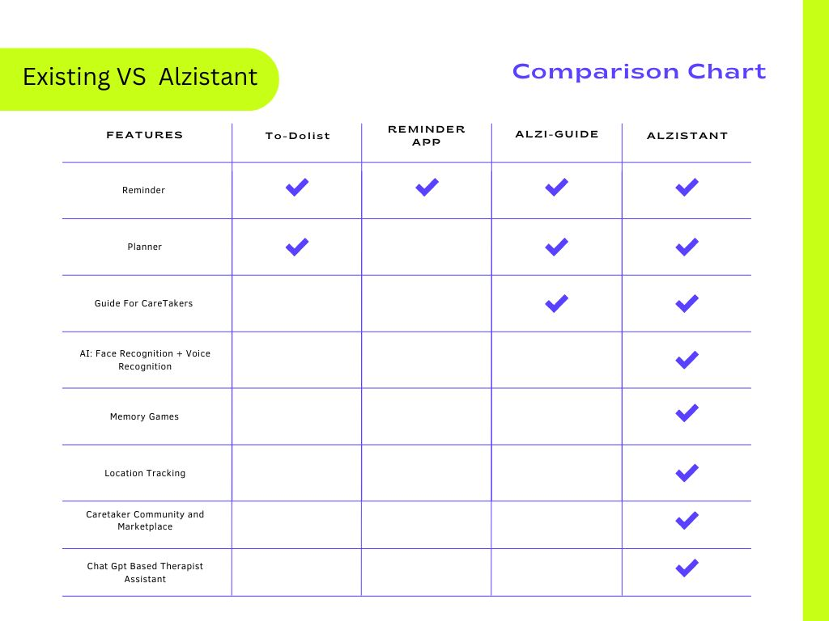

*FIG 3.2.1 Comparison Between Existing and Offered Solutions*

The problem statement of this project is to provide an efficient application by integrating Artificial Intelligence with end-to-end development that offers double solutions to the distressing behavioral issues and communication problems that dementia patients and their caregivers frequently face.

When comparing this project with existing solutions, the solutions available in the market are either very basic or unable to solve any problems in this domain. These aren’t specifically meant for the patients and are not available on one platform. Some examples of existing solutions are to-do lists, reminder apps and dementia guides. This AI based model offers several features that go beyond the existing solutions. For example, it includes face and voice recognition to help patients recognize their family and friends who tend to forget, GPS tracking, an AI-based virtual assistant, games to enhance their cognitive abilities, and a platform to connect with volunteers for caretaking. Therefore, this project aims to bridge the gap between existing solutions and the requirements of dementia patients and their caregivers by providing an all-in-one platform with various features that cater to their specific needs.

**3.4 Gap Analysis**

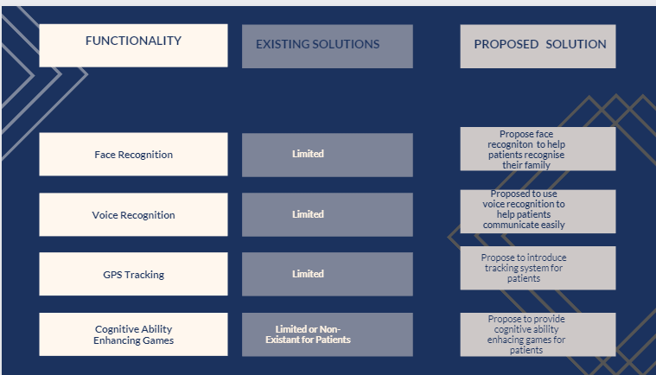

*FIG 3.4.1. Gap Analysis Table 1*

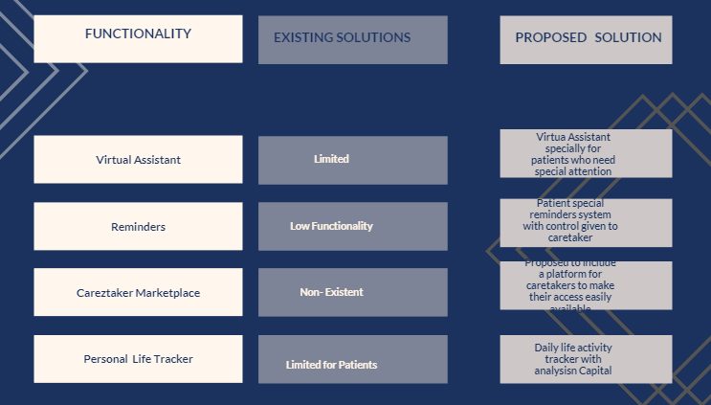

*FIG 3.4.2. Gap Analysis Table 2*

Based on this gap analysis, the proposed solution offers a range of features that are currently unavailable in existing solutions. By integrating various advanced technologies such as face and voice recognition, GPS tracking, AI chatbots, and smart games, the proposed application aims to provide a comprehensive solution for patients with dementia and their caregivers.

**3.5 Feasibility Study**

The purpose of this feasibility study is to determine whether the AI-based Assistant for this project is feasible to implement. This study will cover the technical, operational, and economic aspects of the project.

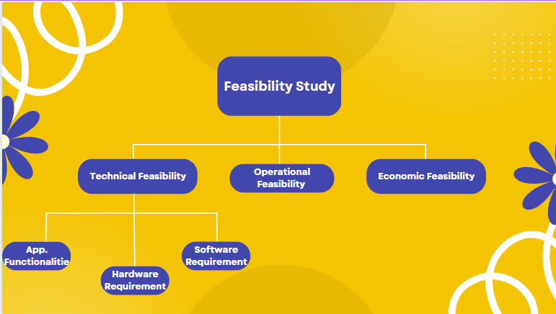

*FIG 3.11. Feasibility Study and Types*

**3.5.1. Technical Feasibility**

The tech. feasibility of the project will be evaluated based on the availability of required hardware and software.

**App Functionalities:**

* + - Face Recognition
    - Voice Recognition
    - GPS Tracking
    - Smart Memory Boosting Games
    - AI Chatbot and Assistant
    - Reminders
    - Caretaker Marketplace
    - To do Lists
    - Personal Life Tracker

**Hardware Requirements:**

* Camera
* Microphone
* Laptop
* GPS System
* Phone (Android/iOS)

**Software Requirements:**

* Jupyter
* Myro
* Visual Studio Code
* Xcode
* Canva
* Figma
* Android Studio Code

**3.5.2. Operational Feasibility**

The project aims to provide two interfaces, one for the patient and the other for the caretaker. The patient interface includes features like recognition of people, things and places related to them, setting reminders, playing games to challenge their cognitive capabilities, and AI assistant for any help. The caretaker interface includes features like keeping track of the patient, adding reminders, editing information, and assisting them virtually in a smart way without any hassle. The operational feasibility of the project will be evaluated based on the ease of use of the application, accessibility, and acceptance of the technology by the users. After the evaluation, it was found that the project is operationally feasible.

**3.5.3. Economic Feasibility**

The project requires the procurement of hardware, software, and the services of skilled personnel for development, testing, and maintenance. The economic feasibility of the project will be evaluated based on the cost of development, expected return on investment, and potential risks. After the evaluation, it is found that the project is economically feasible.

**CHAPTER 4**

**DESIGN AND IMPLEMENTATION**

**4.1 Objective**

1. The objective of this project is to offer intelligent application-based support with features such as Face Recognition, designed to assist patients in identifying their loved ones. Additionally, the application includes functionality such as Pill Reminders and Location Tracking to aid caregivers. Memory Games and a Paint Board are also available to engage patients.
2. This project aims to establish a community and marketplace of proficient caretakers and service providers, while providing the best guidance to caregivers based on the ultimate objective is to enhance patients' quality of life by simplifying their daily chores and saving caregivers' time.rs the best advice based on the patients' needs. The goal is to improve patients' quality of life by making their daily tasks more manageable and saving time for their caretakers.

**4.2 Tools/Platforms Used**

* + AWS:
    - S3 Bucket
    - DynamoDB
    - Lambda Function
    - Face Rekognition
    - IAM Roles
  + Rasa
  + React Native
  + NodeJS
  + Open AI
  + VS Code
  + WebStorm
  + Twilio

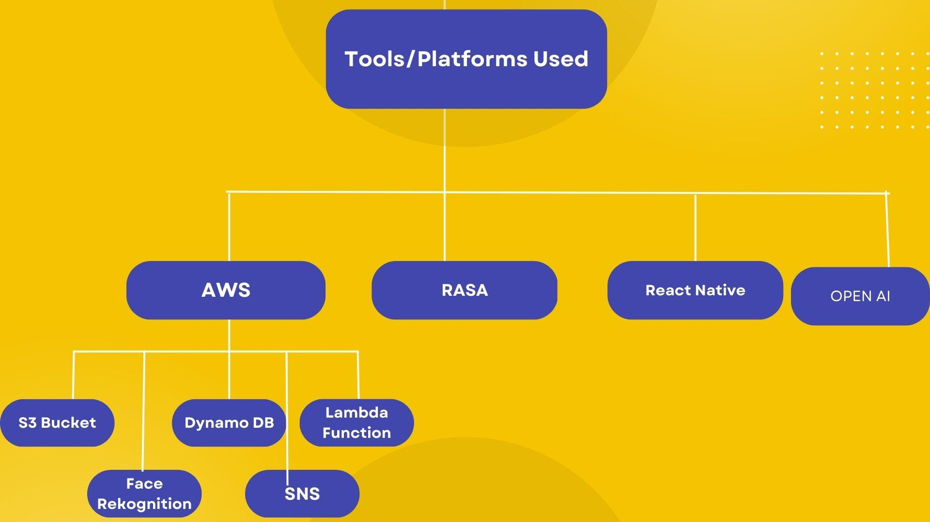

*FIG 4.2.1. Tools/Platforms Used*

**4.3 Detailed Explanation of Tools/Platforms Used**

**4.3.1 AWS**

AWS is a platform for cloud computing that provides businesses and individuals all over the world with a range of scalable, dependable, and affordable services. AWS offers many other services in addition to computing, storage, databases, analytics, machine learning, security, and application development.

AWS offers an Infrastructure-as-a-Service (IaaS) model that enables users to instantly access and control virtual servers, storage, and networking resources. AWS also provides a Platform-as-a-Service (PaaS) model, which lets programmers create and launch cloud-based apps with no concern for the supporting infrastructure.

Applications can handle traffic spikes and continue to be accessible even when hardware fails thanks to the highly available, fault-tolerant, and scalable nature of AWS's services. AWS also offers a variety of tools and services to automate deployments, monitor and manage infrastructure, and apply security best practices.

Overall, AWS offers a reliable and adaptable cloud computing platform that frees companies from the burden of managing infrastructure and allows them to innovate and scale quickly.

**(i) S3 Bucket**

The cloud-based object storage service Amazon Simple Storage Service (S3) is provided by Amazon Web Services (AWS). It offers IT teams and developers a scalable, reliable, and secure storage infrastructure for storing and retrieving data from any location.

The basis of S3 storage is the idea of "buckets," which are essentially storage containers for data objects. Every bucket has a distinct name, which is required to be universally unique across all S3 users. S3 supports multiple access control mechanisms to secure your data and offers API and web interface access to data stored in S3 buckets.

S3 buckets provide 99.99% object durability and are very dependable. In the unlikely event of data loss, S3 can recover your data with little to no downtime, according to this. Versioning, which enables you to track changes to your data over time, and lifecycle policies, which automate the process of moving objects between different storage classes to reduce costs, are additional features offered by S3.

In conclusion, AWS S3 buckets offer a safe, dependable, and scalable object storage solution that enables you to store and access any volume of data from any location. It is a well-liked option for cloud data management and archiving due to its attributes like robustness, scalability, and flexibility.

**(ii) Dynamo DB**

Amazon Web Services (AWS) offers Amazon DynamoDB, a fully managed NoSQL database service. It offers a database solution that is highly scalable, quick, and adaptable and can manage any volume of data and traffic. Modern cloud applications benefit greatly from the fault tolerance, durability, and high availability of DynamoDB.

Data is stored in documents that resemble JSON files called items because DynamoDB is a document-based database. Each item is made up of a primary key that identifies it specifically and one or more attributes that describe the information it contains. Since DynamoDB has no schema, you can change an item's attributes whenever you want without having an impact on the other items in the table.

Highly scalable, DynamoDB can adapt its resources to accommodate any volume of traffic and data. You can create tables with practically infinite storage and throughput capacities, and DynamoDB will automatically partition the data across multiple servers to ensure high performance and availability.

Data access options offered by DynamoDB are varied and include straightforward key-value operations, intricate queries using secondary indexes, and streaming APIs for real-time data processing. To create scalable and serverless applications, you can combine DynamoDB with other AWS services like AWS Lambda, Amazon API Gateway, and Amazon CloudWatch.

Because DynamoDB is a fully managed service, you can focus on creating your applications while AWS handles infrastructure upkeep, backups, and maintenance. It also provides multiple security features, including encryption at rest and in transit, access control using AWS Identity and Access Management (IAM), and compliance with multiple industry standards.

In summary, Amazon DynamoDB is a cutting-edge database solution for cloud applications that is quick, flexible, and highly scalable. It is a well-liked option for developing highly available and scalable cloud applications because of its features like automatic scaling, flexible data access, and full management.

**(iii) Lambda Function**

Amazon Lambda is a serverless computing service provided by Amazon Web Services (AWS). It makes it possible for programmers to execute code without provisioning or managing servers, which makes it a great option for creating scalable and event-driven applications.

Code snippets known as lambda functions can be created in several languages, including Node.js, Python, Java, C#, and Go. Lambda functions can be started by a variety of things, such as API Gateway requests, changes to S3 buckets, and messages in SNS or SQS.

Highly scalable Lambda functions can automatically scale up or down in response to incoming traffic and workload. Since they are billed based on the number of requests and the amount of computer time used, lambda functions are a cost-effective way to run code.

Because they are stateless by design, lambda functions don't keep any state between requests. To store and retrieve data, Lambda functions can communicate with other AWS services like DynamoDB, S3, and RDS.

In addition to direct deployment from the AWS console, deployment via the AWS CLI, and deployment via third-party tools like Serverless Framework and AWS SAM, Lambda functions also offer a variety of other deployment options.

Lambda functions offer a variety of security features, such as integration with AWS Key Management Service (KMS), access control using IAM, and encryption both at rest and in transit.

In conclusion, serverless computing services like Amazon Lambda offer a versatile, scalable, and economical way to run code in the cloud. It is a well-liked option for developing cutting-edge and scalable cloud applications due to its features like event-driven architecture, automatic scaling, and simple deployment.

**(iv) AWS Face Recognition**

Amazon offers a cloud-based facial recognition service called the Rekognition API through Amazon Web Services (AWS). It is made to give developers and businesses extremely quick and accurate facial analysis and recognition capabilities.

AWS Rekognition API uses deep learning algorithms to analyze images and videos, and can identify faces, compare faces, and detect facial attributes such as age, gender, emotions, and facial expressions. The API can also perform real-time facial recognition and provide live video analysis.

The simplicity of use of the AWS Rekognition API is one of its main advantages. It offers a straightforward API interface that is simple to integrate into any program or service. The API can process images and videos in a wide range of formats and can even recognize faces in low-light or low-quality images.

Another benefit of AWS Rekognition API is its scalability. The API is highly scalable and can process millions of images and videos in real-time, making it suitable for use in large-scale applications and services.

However, it is important to note that there are potential privacy concerns associated with facial recognition technology. AWS Rekognition API has faced criticism for its use by law enforcement agencies and its potential for misuse. Developers and companies must be aware of these issues and employ the technology in a moral and responsibly.

Overall, AWS Rekognition API is a robust and extremely precise facial recognition service with a wide range of business and development applications. It offers a high level of accuracy and reliability while being simple to use, scalable, and offering.

**4.3.2 RASA**

Rasa is an open-source framework for creating chatbots and other conversational AI applications. It is intended to give programmers a flexible and adaptable platform for creating intelligent chatbots that can comprehend natural language and give users helpful responses.

Rasa NLU and Rasa Core are the two main parts of the Rasa framework. Rasa NLU oversees comprehending user input and gleaning pertinent data from it. It recognizes entities, intents, and context in the user's message using machine learning techniques.

Rasa Core, on the other hand, oversees managing the dialogue and producing suitable responses in response to user input. Based on the current state of the conversation, it employs a probabilistic model to forecast the subsequent action.

The flexibility and customizability of the Rasa framework are two of its main benefits. It enables developers to define their own intents, entities, and actions to produce highly customized conversational experiences. Additionally, a variety of integrations with well-known messaging services like Slack, Facebook Messenger, and WhatsApp are supported.

The emphasis Rasa places on open standards and interoperability is another benefit. TensorFlow and Scikit-Learn, two widely used machine learning libraries, are used by the framework, which is built on top of Python. This makes it easy to integrate with other tools and systems.

But it's crucial to remember that creating a productive conversational AI application calls for careful planning and design. The Rasa framework gives programmers the building blocks they need to create intelligent bots, but it is up to the programmers to create a conversational flow that is user-friendly and helpful.

Rasa is a strong framework for creating conversational AI applications that can comprehend natural language and give users helpful responses. It is a popular option for developers and businesses alike because it is adaptable, customizable, and supports a wide range of integrations.

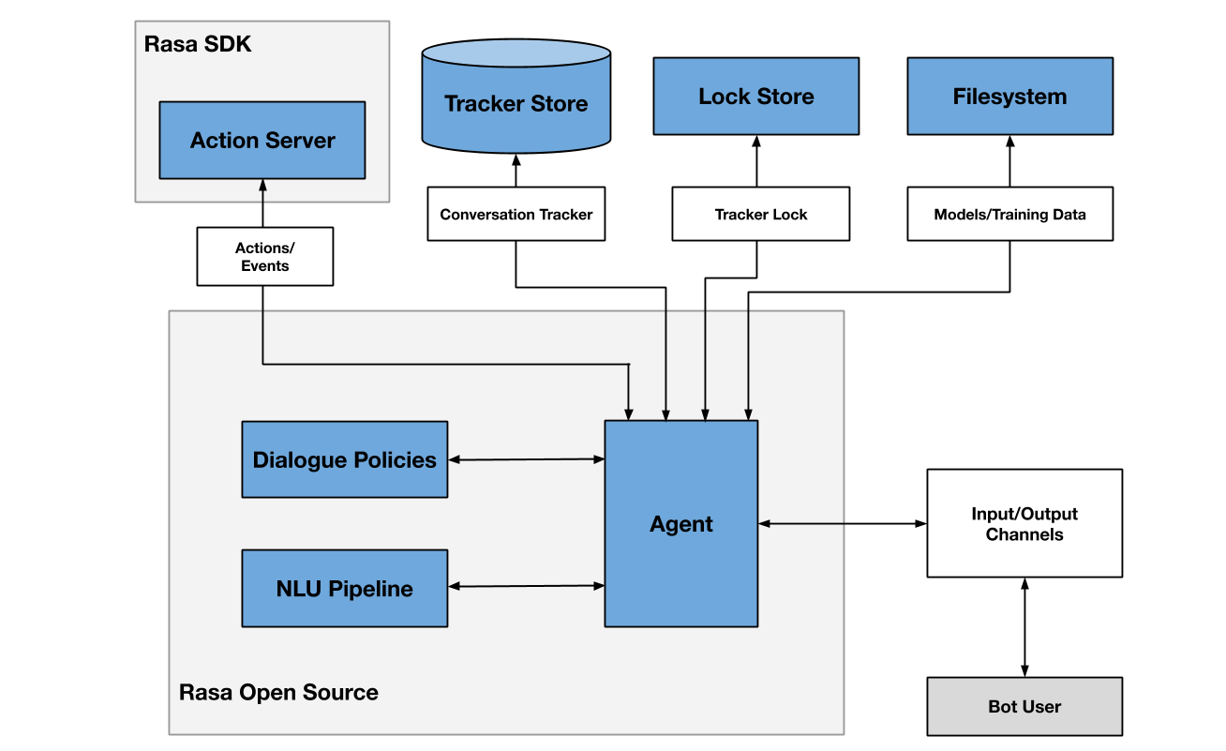

*FIG 4.3.2.1. Rasa Architecture*

**4.3.3 REACT NATIVE**

The well-known open source React Native mobile application framework was created by Facebook. It allows developers to produce native mobile apps for iOS, Android, and other platforms using JavaScript and React.

With React Native, programmers can write JavaScript code and have it run natively on mobile devices by using a bridge to communicate with native components and APIs. Compared to hybrid app development, which uses web views to render the app's user interface, this offers a more seamless user experience.

One of React Native's key benefits is its cross-platform functionality, which enables programmers to create apps for various platforms using a single codebase. This not only saves time and effort, but it also lowers the price of creating an app. Additionally, React Native provides an extensive library of pre-built components that make it simple for developers to design beautiful, responsive user interfaces for their applications.

React Native's hot-reload feature, which enables developers to see their code changes in real-time without having to recompile the entire app, is another significant benefit. The development process can be greatly accelerated, and productivity can rise.

Furthermore, the React Native framework has a sizable and active community that provides thorough support, thorough documentation, and a wide range of third-party libraries and plugins to expand the framework's functionalities.

Overall, React Native is a powerful tool for mobile app development that offers many advantages, including cross-platform capabilities, pre-built components, hot-reload, and an active community. With its growing popularity, it is likely to continue to be a popular choice for developers seeking to create high-quality mobile apps efficiently and cost-effectively.

**4.3.4 NODE JS**

A cross-platform, open-source runtime environment called Node.js enables programmers to create JavaScript-based server-side applications. Node.js offers a lightweight, event-driven architecture that is suitable for creating scalable, high-performance applications. It is based on the same V8 JavaScript engine that powers Google Chrome.

Node.js's ability to manage numerous concurrent connections without the need for multi-threading is one of its main advantages. This is made possible by Node.js' event-driven, non-blocking I/O model, which enables it to process numerous requests concurrently while using a minimum number of resources.

Additionally, Node.js is very modular and has a robust ecosystem of third-party modules and packages that are accessible via its npm package manager. This saves time and effort by enabling developers to quickly incorporate pre-existing libraries and tools into their projects.

Being compatible with JavaScript, one of the most popular programming languages in the world, is another important benefit of Node.js. This reduces the learning curve and increases productivity by facilitating the switch from front-end to back-end development using the same language.

Node.js is also well suited for creating real-time applications like chat programs, multiplayer games, and collaboration tools that need regular data updates and transfers between the client and server.

Overall, Node.js is a strong and adaptable tool for creating server-side JavaScript applications. Developers looking to create high-performance, scalable applications that can handle high volumes of traffic and data frequently choose it because of its event-driven architecture, modular design, and compatibility with JavaScript.

**4.3.5 OPEN AI’s GPT3.5 TURBO API**

Open Ai’s most sophisticated language model, gpt-3.5-turbo, is the engine behind ChatGPT.

You can create your own programs with gpt-3.5-turbo and the Open AI API to accomplish tasks like:

• Create an email or other written document

• Creating Python code

• Respond to inquiries regarding a set of documents

• Construct conversational robots

• Make a natural language user interface for your software

• tutor for various subjects

• Language translation

• Simulate video game characters, among other things

Prior responses are saved thanks to the assistant messages. To help illustrate desired behavior, they can also be written by developers.

When user instructions refer to earlier messages, including the conversation history is useful. In the example, the user's last query, "Where was it played?", only makes sense considering the earlier communications regarding the World Series of 2020. All pertinent information must be provided via the conversation because the models don't remember previous requests. A conversation must be shortened in some way if it exceeds the model's token limit.

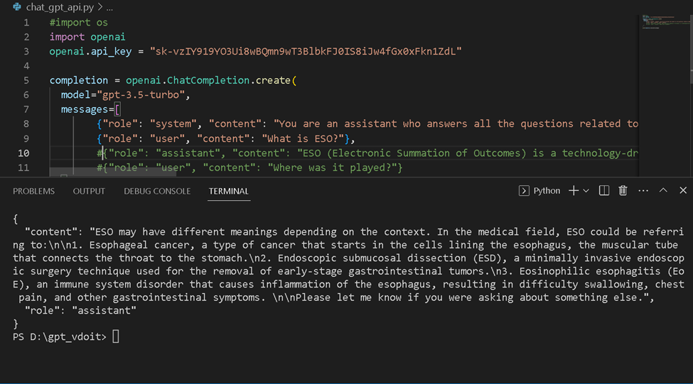

*Fig 4.3.5.1 An example API response*

**4.3.6 VS CODE**

Visual Studio Code (VS Code) is a popular, open-source code editor developed by Microsoft. It is designed to be highly customizable and extensible, providing a wide range of features and tools to enhance the development experience for developers.

One of VS Code's unique features is its sizable library of extensions, which enables programmers to add new features and functionality to the editor. Many different programming languages and development methodologies are covered by the thousands of extensions available in the Visual Studio Marketplace.

In addition, VS Code has a ton of built-in tools to increase developer productivity, such as a powerful code editor with code refactoring, syntax highlighting, and automatic code completion. Additionally, VS Code comes with a ton of built-in tools to boost developer productivity, including a robust code editor with automatic code completion, syntax highlighting, and code refactoring. The editor serves as a one-stop shop for many developers thanks to its debugging tools, version control integration, and built-in terminal.

Cross-platform compatibility with Windows, Mac, and Linux operating systems is another significant benefit of VS Code. As a result, teams with members using various platforms frequently choose it because it enables smooth workflow and collaboration.

There are numerous tutorials, tools, and plugins for VS Code's large and vibrant community of developers to help them get started and expand the editor's functionality.

In general, VS Code is a strong, flexible code editor that works well with a variety of programming languages and development processes. Its extensive feature set, availability across platforms, and vibrant community make it a popular option for developers looking to increase output and simplify processes.

**4.3.7 WEB STORM**

JetBrains created the well-liked and potent Integrated Development Environment (IDE) known as WebStorm. It offers a variety of tools and features that are tailored specifically for web development, enhancing developer productivity, and streamlining the development process.

Its intelligent coding assistance, which offers smart code completion, error highlighting, and code refactoring for a variety of programming languages, including HTML, CSS, JavaScript, TypeScript, and more, is one of WebStorm's key benefits. This facilitates the quick and effective writing of high-quality, error-free code by developers.

A variety of debugging and testing tools are also included in WebStorm, such as live editing, a JavaScript debugger, and compatibility with well-liked testing frameworks like Jest and Mocha. This makes sure that their code is operating as intended and enables developers to identify errors early.

Another key advantage of WebStorm is its integrated version control, which allows developers to manage their code repositories directly within the IDE. This includes support for Git, Mercurial, and Subversion, as well as code review tools to facilitate collaboration and code quality control.

WebStorm also includes a range of productivity features, such as live templates, code snippets, and keyboard shortcuts, which help developers save time and streamline their workflow. It also has built-in support for popular front-end frameworks like React, Angular, and Vue, providing a seamless development experience for these frameworks.

Overall, WebStorm is a powerful IDE that provides a range of tools and features to improve developer productivity and streamline the web development process. Its intelligent coding assistance, debugging and testing tools, integrated version control, and productivity features make it a popular choice for web developers seeking a comprehensive and efficient development environment.

**4.3.8 Twilio**

With the help of the cloud communications platform Twilio, companies can connect with their clients via voice, text, video, and email, among other channels. Developers can create and incorporate communication features into their applications, websites, and services using the platform's wide array of APIs and SDKs.

Some of the key features and services offered by Twilio include:

* **Programmable Voice is a cloud-based service that gives companies the ability to make and receive voice calls, develop custom call extensions, and build automated phone menus.**
* **Programmable SMS:** A service that enables companies to send and receive texts as well as create automated messaging workflows.
* **Video:** A service that allows businesses to add live video and audio to their applications, websites, and services.
* **Email:** A service that enables businesses to send and receive email messages through Twilio’s API.
* Channels for Messaging: Twilio supports several channels for messaging, including SMS, WhatsApp, Facebook Messenger, and others.
* **Authentication:** Twilio offers a range of tools for authentication and authorization, including two-factor authentication, phone number verification, and authorization.
* **Analytics:** Businesses can track and evaluate the effectiveness of their communication channels and campaigns using the detailed analytics and reporting tools provided by Twilio.

Businesses of all sizes and from a variety of sectors, such as healthcare, finance, retail, and more, use Twilio. It offers a flexible and scalable platform that can be tailored to meet the needs of developers and businesses looking to add communication features to their applications and services.

**4.4 Design Methodology: Agile Methodology**

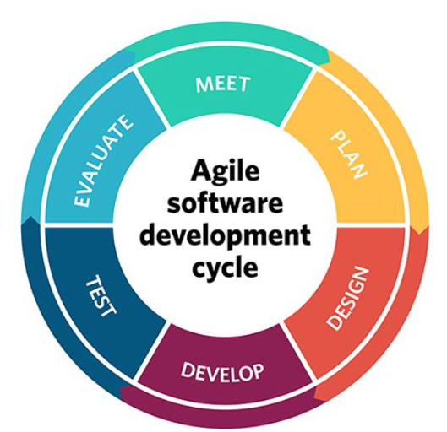

*Fig 4.4.1 A Visual Representation of Agile Methodology*

Software development using the agile methodology is incremental and iterative, with a focus on flexibility, collaboration, and client satisfaction. The Agile Manifesto, which was developed in 2001 by a group of programmers looking to improve the traditional waterfall-style approach to software development, serves as its foundation.

* The Agile methodology emphasizes the following fundamental principles:
* As opposed to methods and tools, it is people and interactions.
* Software that works better than extensive documentation
* participation of the client in the contracting process
* Changing with the times versus following a plan

The development process is divided into shorter, more manageable segments called sprints, which typically last one to four weeks, according to the Agile methodology. For each sprint, several tasks or user stories are given to a cross-functional team of developers, testers, and other stakeholders.

With daily stand-up meetings to review progress and address any issues, the Agile methodology strongly emphasizes teamwork and communication. It also places a high priority on customer involvement and feedback along with routine reviews and demonstrations to ensure the product being developed satisfies the customer's needs and requirements.

Two of the main advantages of the Agile methodology are its adaptability and flexibility.

In general, the Agile methodology, which emphasizes adaptability, teamwork, and client satisfaction, is a well-liked approach to developing software. Due to its iterative and incremental approach, focus on cross-functional teams, and emphasis on customer feedback and involvement, it is a well-liked choice for teams looking for an effective and efficient development process.

**CHAPTER 5**

**TESTING AND DEPLOYMENT**

**5.1 Modules & Their Deployment**

Artificial intelligence (AI), machine learning (ML), natural language processing (NLP), computer vision, and other cutting-edge technologies are all used in each module of our project. These modules were painstakingly developed to address specific functionalities and enhance our application's overall capabilities.

**5.1.1 Face Recognition**

This feature is particularly important for patients with dementia, as forgetting familiar faces can be a significant challenge for them. As a result, we have decided to include this feature in our application.

Face recognition can be used to help the patient communicate with caregivers and loved ones. For example, a device could display the name and relationship of the person standing in front of the patient, helping them remember who they are and what their relationship is.

Overall, the use of face recognition technology can help improve the quality of care for patients with dementia, while also enhancing their safety and well-being.

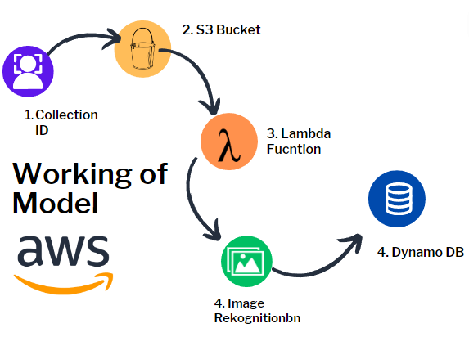

*FIG 5.1.1. Steps for Face Recognition Model*

**Steps For AWS Face Recognition:**

1. Open Windows PowerShell.
2. AWS Shell was installed.
3. Use command aws configure.
4. Enter authentication key.
5. Enter secret security key.
6. Enter zone: east-us-1.
7. Created a collection in Aws Face Rekognition. Named: facerecognition_collection
8. Created a table on DynamoDB. Named: face_recognition
9. Created an S3 bucket. Named: recognise-people-images
10. Create lambda function Named: facerecognition.
11. Create an IAM policy to let lambda access facerecognition api and s3 bucket, dynamodb table to recognise a person. Python Script to input images and their metadata (full name) into S3 Bucket.
12. Added trigger to lambda function: wherever an image is added to the bucket the function triggers and calls for facerekognition api and does all the necessary steps to recognise a person.
13. Written a python script to input an image and recognize that person.

**Scope of improvement**

In addition to recognizing the name of the person, we can also include their relationship with the patient and other relevant information. These details can be added by the caregiver, who will have access to a database of all people.

**5.1.2 Cognitive Games**

Cognitive games are activities or games that are designed to stimulate the brain and improve cognitive function, such as memory, attention, reasoning, and problem-solving. These games are often used as part of cognitive therapy or rehabilitation for people with weaker memory or dementia, as they can help slow down the progression of the disease and improve the person's quality of life.

Here are some ways that cognitive games can help a person with weaker memory or dementia:

1. **Memory Improvement:** Cognitive games can help improve memory retention, by providing a fun and engaging way for the person to exercise their memory and recall abilities. This can help slow down memory loss and delay the onset of dementia.
2. **Attention and concentration:** Cognitive games can help improve attention and concentration, which can help the person stay engaged and focused, which can lead to better cognitive performance.
3. **Mental Stimulation:** Cognitive games provide mental stimulation, which can help slow down cognitive decline and improve overall brain health. By engaging in challenging mental activities, the brain is encouraged to form new neural connections, which can help improve cognitive function.

**5.1.3 Virtual Assistant (Chat GPT BASED Chatbot)**

The communication and cognitive abilities of patients may be affected by dementia, a disease that progresses over time. Dementia patients' family members and caregivers frequently struggle to offer the necessary support, especially when the patients have trouble communicating. To solve this problem, we created a chatbot that helps dementia patients using the conversational AI platform Rasa. The chatbot uses Twilio API to send messages to caregivers when patients enter trigger words like "help" or "caretaker," and GPT API, which is tailored to behave like a therapist.

**Features:**

Our chatbot employs Rasa to comprehend user input in natural language and provide pertinent messages in response. It has been trained in a variety of words and sentences that people with dementia might use to communicate. The GPT API is activated to deliver an appropriate response if the patient inputs a question or statement that the chatbot is unable to understand. The chatbot is now more versatile and able to handle a wider range of inputs and circumstances because of the integration of the GPT API. Additionally, when patients enter trigger words like "help" or "caretaker," the chatbot can instantly send messages to caregivers thanks to the Twilio API integration. It also has content filtering/moderation to prevent users from sending any toxic messages to our bot or even avoiding bot from responding in any hateful manner.

**Content Moderation:** Dl-NLP based content moderation.

For training this content moderation model, following steps were followed:

* **Importing necessary libraries:** The code starts by importing required libraries such as os, pandas, TensorFlow, and NumPy.
* **Loading and preprocessing data:** The code loads the toxic comment data from a CSV file using pd.read_csv. It then separates the input features **(X)** and target labels **(y)** from the data frame.
* **Text vectorization:** The Text Vectorization layer from TensorFlow is used to tokenize and vectorize the comment text. The vectorizer is adapted to the input text data, and the comment text is transformed into a sequence of integers using vectorizer.
* **Creating the dataset**: The code creates a TensorFlow dataset using **tf.data.Dataset.from_tensor_slices** by combining the vectorized text data and the target labels. The dataset is then cached, shuffled, batched, and prefetched for efficient processing.
* **Model architecture**: A sequential model is created using **Sequential()** from Keras. The model architecture includes an embedding layer, a bidirectional LSTM layer, fully connected layers for feature extraction, and a final dense layer for multi-label classification.
* **Model compilation and training:** The model is compiled using binary cross-entropy loss and the Adam optimizer. It is trained using the training dataset **(train)** for one epoch with validation data **(val)** for evaluation. The training history is stored in history.
* **Plotting training history:** The training history, including the loss and validation metrics, is plotted using matplotlib to visualize the model's performance during training.
* Prediction: An input text is provided to the vectorizer for preprocessing. The preprocessed text is then passed to the trained model **(model.predict)** to obtain predictions for toxic labels.
* **Importing necessary libraries:** The code starts by importing the required libraries, including TensorFlow, Gradio, and the necessary metrics.
* **Metrics initialization:** Precision **(pre),** recall **(re),** and categorical accuracy **(acc)** metrics are initialized using the respective classes from **tensorflow.keras.metrics.**
* Evaluation loop: The code iterates over the batches in the test dataset using **test.as_numpy_iterator().** For each batch, it unpacks the input features **(X_true)** and target labels **(y_true).**
* **Prediction:** The model is used to make predictions **(model.predict)** on the input features **(X_true).**
* **Flattening predictions:** The target labels and predictions are flattened using **flatten() to** match the expected shape for the metric calculations.
* **Metric updates:** The precision, recall, and accuracy metrics are updated using the **update_state()** method, which takes the true labels **(y_true)** and predicted labels **(yhat).**
* **Printing results:** The precision, recall, and accuracy metrics are printed using **pre.result().numpy(), re.result().numpy(),** and **acc.result().numpy(),** respectively. The **result()** method returns the current value of the metric.
* **Saving and loading the model:** The trained model is saved to a file named "toxicity.h5" using **model.save().** Later, the model is loaded back into the model variable using **tf.keras.models.load_model().**
* **Scoring comments with the model:** The code defines a function named **score_comment** that takes a comment as input. The comment is vectorized using **vectorizer** and passed to the loaded model **(model.predict)** to obtain predictions. The results are formatted into a text string indicating the toxic labels and whether each label is predicted as True or False.
* **Gradio interface creation For Testing:** The **gr.Interface** class is used to create a Gradio interface. It takes the **score_comment** function as the scoring function, specifies a text input textbox, and sets the output to be text. The interface is then launched using **interface.launch(share=True)** to make it accessible in a web browser.



*Fig 5.1.3 Model Accuracy*

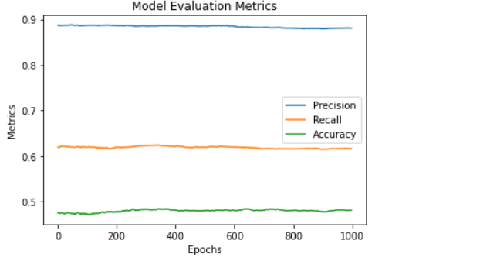

*Fig 5.1.3 Graphical Representation of Evaluation Matrix*

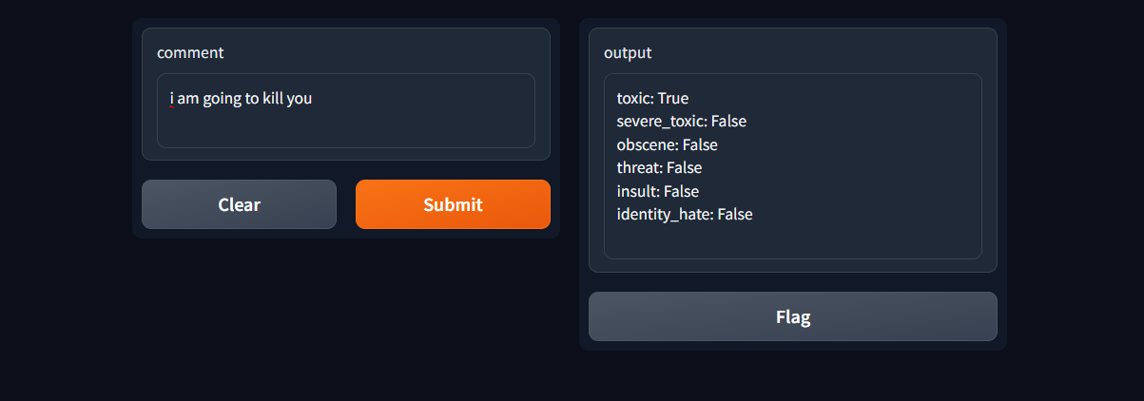

*Fig 5.1.3.1 Model Testing on Gradio*

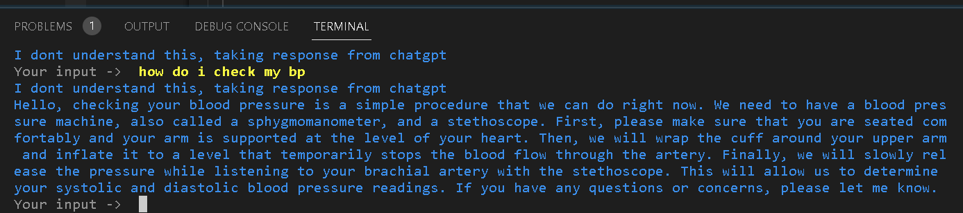

*Fig 5.1.3.1 Working chatbot Backend Snippet*

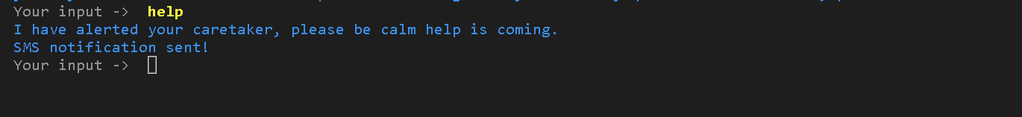

*Fig 5.1.3.2 Working chatbot Backend Snippet*

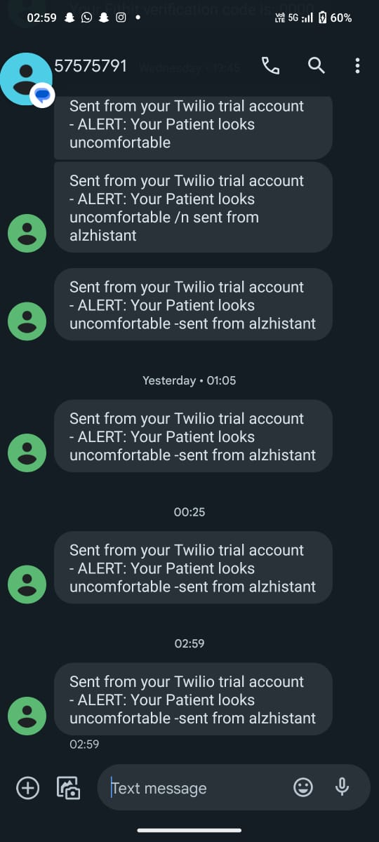

*Fig 5.1.3.3 Message Alert from Patient*

**Use Cases for Chatbot:**

* The Rasa-based chatbot for dementia patients has several use cases, including:
* **Providing 24/7 support:** The chatbot is available 24/7, providing continuous support to patients. Caregivers can rely on the chatbot to aid when they are not available.
* **Reducing caregiver burden:** Caregivers often experience stress and burnout due to the demands of caring for dementia patients. The chatbot can help reduce this burden by providing support to patients and freeing up caregivers' time.
* **Improving patient communication:** Patients with dementia may find it hard to communicate with their caregivers. The chatbot offers an intuitive interface that is easy for patients to use and understand, improving their communication with caregivers.
* **Alerting caregivers in emergencies:** The Twilio integration enables the chatbot to send messages to caregivers in real-time when patients input trigger words such as "help" or "caretaker." This feature can be especially useful in emergencies when patients require immediate assistance.

**Scope of Improvement in Chatbot:**

* The Rasa-based chatbot for dementia patients has a promising future scope. Here are some potential areas for future development:
* **Adding voice support:** Adding voice support to the chatbot can make it even more accessible to dementia patients who may have difficulty typing.
* **Integrating with smart home devices:** Integrating the chatbot with smart home devices can enable it to provide even more support to patients, such as turning on lights or adjusting the thermostat.
* **Customizing responses:** Customizing the chatbot's responses based on patients' individual needs can improve the chatbot's effectiveness in providing support.
* **Expanding to other languages:** Expanding the chatbot to support other languages can make it accessible to a wider range of patients worldwide.

**Testing and Evaluation of Smart Assistant Rasa Model**

**Evaluation on Conversation Level:**

* **Correct**: This indicates the number of correctly predicted conversations out of the total evaluated conversations. In our case, 6 out of 7 conversations were predicted correctly.
* **Accuracy:** This is the accuracy of conversation-level predictions, calculated as the ratio of correctly predicted conversations to the total number of conversations. In our case, the accuracy is 0.857 (or 85.7%).
* 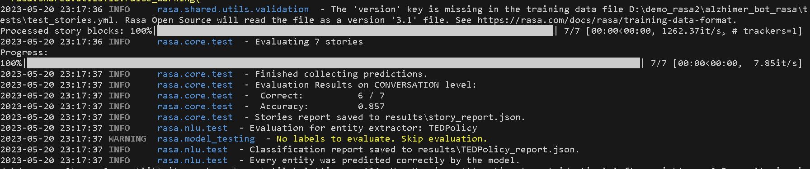
* Evaluation on ACTION level:
* 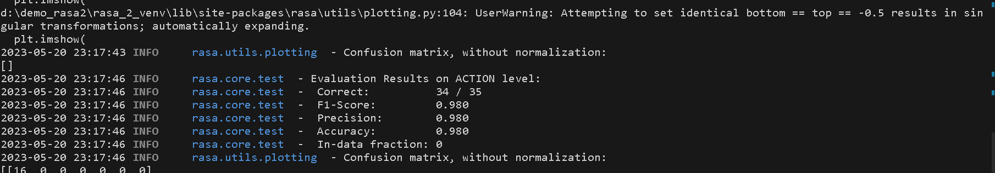
* **Correct:** This indicates the number of correctly predicted actions out of the total

evaluated actions. In our case, 34 out of 35 actions were predicted correctly.

* **F1-Score:** The F1-score is a measure of the model's performance that considers both precision and recall. It is calculated as the harmonic mean of precision and recall. In our case, the F1-score is 0.980, which indicates high performance.
* **Precision:** Precision is the ratio of true positive predictions to the total number of positive predictions. It measures the model's ability to avoid false positives. In our case, the precision is 0.980 (or 98.0%).
* **Accuracy:** This is the accuracy of action-level predictions, calculated as the ratio of correctly predicted actions to the total number of actions. In our case, the accuracy is 0.980 (or 98.0%).
* In-data fraction: This indicates the fraction of the training data that was used for evaluation. In our case, the evaluation was performed on the entire training data (100%).
* Overall, our model has shown good performance in predicting both conversations and actions, with high accuracy and F1-scores.

**5.1.4 Backend:**

**Introduction:**

Node.js is an open-source, cross-platform runtime environment that utilizes Chrome's V8 JavaScript engine. It is well known for its capacity to develop highly effective, scalable applications with real-time communication features. In-depth instructions on how to construct a dependable backend using Node.js, TypeScript, and Express.js are provided in this documentation. To provide image upload and verification functionalities, we will also integrate crucial services like Amazon S3, Lambda, and DynamoDB. We will also look at the scalability and security benefits of TypeScript and Express.js. The backend will easily handle different services like Face Recognition, chat, gallery, and pill reminder by utilizing loose coupling and a flexible API structure, allowing multiple applications to connect at once.

**Functionality:**

This backend offers an upload endpoint and returns a special name for the image that was uploaded. After the image has been checked, it is uploaded to an Amazon S3 bucket, where it is then processed by a Lambda function before being uploaded to DynamoDB. The metadata for the uploaded images, including their distinctive names, can be stored in the DynamoDB database. This data can be used to run queries on the images, such as looking for images that meet a certain set of requirements.

Additionally, the backend offers a user identity verification endpoint that makes use of facial recognition software. By using this endpoint, a user can take a photo of themselves and check to see if they are who they say they are. This is done by comparing the user's photo to a database of well-known images using a combination of machine learning algorithms and image processing techniques.

**Architecture:**

We use a microservices architecture strategy to create a scalable and modular backend. Each microservice specializes in a single feature or function and interacts with other services via APIs. We develop a flexible and effective architecture that encourages loose coupling and independent scalability of services by utilizing Node.js, TypeScript, and Express.js.

We can independently develop, deploy, and scale each service in accordance with its unique needs by using a microservices architecture. Flexibility, fault isolation, and simple system integration are all made possible by this method. We can build a strong and scalable backend that can support a variety of applications while ensuring security and real-time communication capabilities by leveraging the power of Node.js, TypeScript, and Express.js.

**Backend Server:** For the development of reliable and scalable backend systems, TypeScript Express server coupled with MongoDB is a potent combination**.** Code maintenance is made simpler and code quality is increased thanks to TypeScript's static typing and improved developer tooling. Express.js, a straightforward web framework, makes it possible to handle requests, integrate middleware, and route data effectively. We can store and retrieve data in a flexible and scalable way by integrating MongoDB, a NoSQL database. High-performance, type-safe, and dependable server applications can be created using TypeScript, Express.js, and MongoDB. It offers a strong framework for developing APIs, managing data persistence, and presenting fluid user interfaces.

This backend solution uses Twilio to send OTPs (One-Time Passwords) for mobile verification in addition to the TypeScript Express server connected to MongoDB. With the help of Twilio, applications can easily verify mobile numbers by sending SMS messages on a dependable and secure platform. This feature enhances the security and trustworthiness of user registrations and logins. Additionally, the backend includes "Login with Google" functionality that enables users to log in and authenticate using their Google accounts. By streamlining the login process, this integration offers users a practical and well-liked authentication option. The backend system's capabilities are increased by the integrations with Twilio and Google Login, which also improve security and user experience.

**Redis:** A popular backend for applications is Redis, a high-performance, in-memory data structure server**.** It provides quick read and write operations, flexible data structures, and options for persistent data storage. Redis enables scalable and effective data storage and retrieval for your application.

**Streamlined Login and Verification Process:** Sync Patient Data Effortlessly Using Redis and Google Authentication: During the login or signup process, our backend uses Google authentication to retrieve the most basic user information, including email, name, and photo. The user is asked for their mobile number when authentication is successful. To verify the mobile number, we integrate the Twitch API for sending and verifying OTPs. The OTP is securely stored on a Redis server, ensuring quick retrieval and deletion.

The user gains access as a caretaker and can add patients to their account after the verification process is finished. The special feature is that users don't need to enter any additional information to easily log in using their Google credentials. By eliminating the hassle of double data entry and streamlining the user experience, this seamless login process automatically syncs the patient's data to our database.

Our backend creates a seamless and user-friendly experience for caregivers and patients alike by utilizing Google authentication, secure mobile number verification, and the power of Redis for efficient OTP storage. The simplified procedure guarantees that patients' data is securely stored and synchronized while enabling caregivers to manage patients with ease and offering patients a seamless login experience.

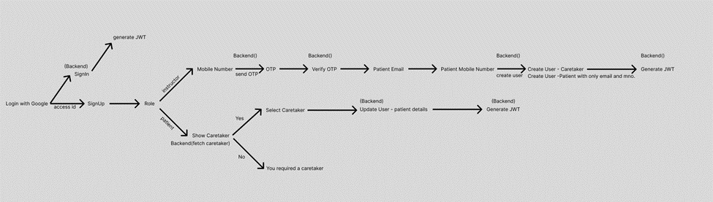

*Fig 5.1.4.1 Flow of Application*

**Amazon S3.** A Lambda function is called to process and upload an image to DynamoDB when it is uploaded to S3.

**Lambda:** Images uploaded to S3 are processed before being uploaded to DynamoDB using the Lambda function**.** The JavaScript function is called when an S3 event occurs.

DynamoDB: DynamoDB is used to store the uploaded images and their associated metadata. The database is partitioned based on the image name to enable efficient queries.

Facial Recognition Service: The facial recognition service is responsible for verifying user identity using facial recognition technology. The service uses machine learning algorithms and image processing techniques to compare the user's photo to a database of known images.

**API Gateway**: The API Gateway serves as the central entry point for client requests, providing a unified API interface. Based on the specified endpoint and HTTP method, it serves as a traffic coordinator, directing incoming requests to the appropriate microservices. Because of Express’s ease of use and adaptability, the API Gateway can be created quickly and effectively. The API Gateway not only handles routing but also crucial jobs like authentication, rate limiting, and request validation. It ensures that only authorized requests are forwarded to the respective microservices, enhances security by implementing authentication mechanisms, and validates the incoming requests for correctness and adherence to predefined standards. The API Gateway plays a crucial role in abstracting the underlying microservices architecture, providing a seamless and cohesive experience for the clients interacting with the backend system.

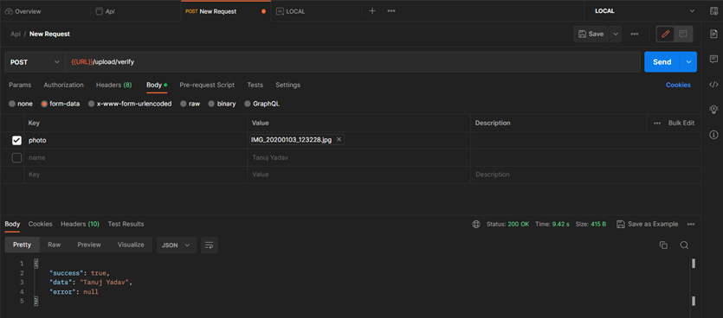

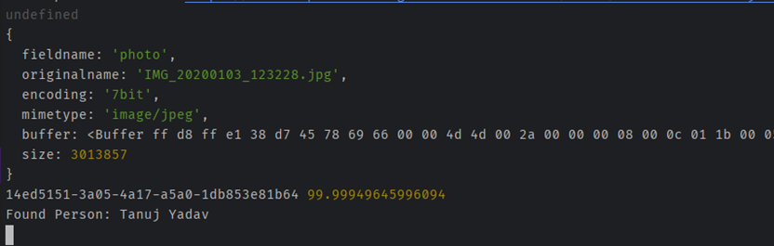 *Fig 5.1.4.3 Face recognition Backend Processing*

**Deployment:**

Utilizing Continuous Integration and Continuous Deployment (CI/CD) techniques for effective and automated deployment processes, our backend is deployed on Vercel. Our backend services are reliable and scalable thanks to the solid platform Vercel offers. Additionally, we use the free tier to host our MongoDB database, making data storage and retrieval simple. We integrate services like Twilio for frictionless communication and AWS for additional cloud capabilities to improve the functionality of our application. By utilizing the advantages of Vercel's deployment platform and the adaptability of MongoDB on the free tier, we can deliver a backend solution that is highly performant and feature rich.

**Vercel**: A cloud platform that provides a robust and scalable environment for hosting backend services.CI/CD: A set of procedures for automating the development, testing, and deployment of software.

MongoDB: A database that provides seamless data storage and retrieval.

Twilio: A platform for cloud-based communications that enables frictionless user-to-user communication.

AWS: A group of cloud computing services that offer extra cloud functionality.

**Conclusion:**

The architecture we've been talking about, which combines Node.js, TypeScript, Express.js, and MongoDB, provides a strong base for creating a reliable and scalable backend system. We gain from static typing, improved developer tooling, effective routing, and request handling by utilizing these technologies. MongoDB, a versatile NoSQL database, enables easy data archiving and retrieval. Security and user experience are further improved by integrating Twilio for mobile OTP verification and "Login with Google" functionality.

This architecture makes it possible to build server applications that are incredibly fast, type-safe, and dependable. It offers a strong framework for creating APIs, managing data persistence, and providing seamless user experiences. Because each service is developed, deployed, and scaled independently using the microservices approach, loose coupling is ensured. The API Gateway serves as a single point of entry and controls request validation, rate limiting, and authentication.

We can create a robust backend using this architecture that can support a variety of functionalities, including image upload and verification, face recognition, real-time chat, gallery management, and medication reminders. The integration of multiple applications is made possible by the loose coupling and flexible API structure, which encourages scalability and simple expansion.

This architecture's overall combination of Node.js, TypeScript, Express.js, MongoDB, Twilio, and "Login with Google" offers a strong foundation for creating a scalable, secure, and feature-rich backend system for your project. It enables efficient development, seamless integration, and reliable performance, ultimately delivering a superior user experience.

**5.1.5 Alzistant Web App (Beta) - Frontend**

Alzheimer's disease is a neurodegenerative condition that progressively impairs memory, thinking, and behavior. Alzheimer's patients frequently struggle with daily tasks like remembering appointments, taking care of their medications, and navigating unfamiliar environments as the disease worsens. For people with Alzheimer's, a web application can be a useful tool to help with these daily tasks. This article talks about creating a React-based app to help those with Alzheimer's.

**Purpose:**

This app's goal is to support people with Alzheimer's in their daily activities. The app aims to provide a user-friendly interface that aids people with Alzheimer's in keeping track of family members, remembering to take their medication on time, accessing a chatbot for assistance in case of emergencies, browsing through a photo gallery to cherish their memories, and using a login and registration feature to create and access their accounts.

The Alzistant Mobile App uses React, a well-known JavaScript user interface library, to create a robust frontend and provide an app-like experience. A seamless and interesting user experience is made possible by Reacts ability to create interactive and responsive components. The app can offer people with Alzheimer's a dynamic and user-friendly interface by making use of Reacts capabilities.

Utilizing React also ensures accessibility to a larger user base during the early stages of development and improves target audience understanding. Because of its adaptability and wide-ranging community support, react is a great option for creating feature-rich, user-centric apps to help people with Alzheimer's get through their daily lives.

The Alzistant Mobile App aims to give people with Alzheimer's a useful tool that improves their quality of life and encourages independence in managing their daily activities by fusing the strength of React with its mission to help them.

You can see an example of the real application below:

**Login /Signup:**

With "Login with Google," our app offers a hassle-free Signup/Login process. With this feature, users can quickly register for or log into the app using their Google account, doing away with the tedious manual entry of name and email information. By integrating "Login with Google," users can quickly access the app's features and services. Additionally, to ensure security and authenticity, a simple mobile verification process is implemented. Once the verification is complete, users can seamlessly navigate through the app and enjoy its functionalities without any unnecessary hurdles. Experience a seamless and efficient Signup/Login experience with our app,

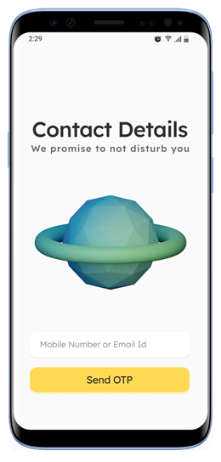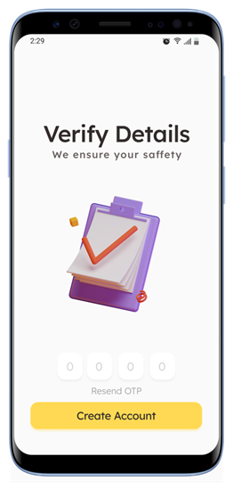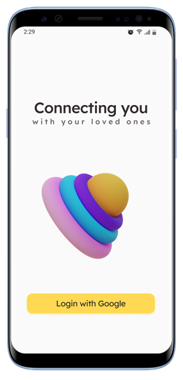

*Fig 5.1.4.4 Webapp Frontend - LOGIN*

The app offers two types of dashboards: one for the patient and another for the caretaker.

**Patient's Dashboard:**

Relatives: Keep track of and manage contact information for family members and caregivers.

Gallery: Access a photo gallery to store and cherish memories.

Pill Tracker: Easily monitor and stay on top of medication schedules.

Chatbot: Get assistance and support through an interactive chatbot.

**Caretaker's Dashboard:**

Relatives: Maintain a list of added relatives and their relevant details.

Gallery: Browse through the photo gallery for the patient, facilitating communication and reminiscing.

Pill Tracker: View and manage the patient's medication schedule and reminders.

Add Pill Reminder: Set up new reminders for medication administration. Chatbot: Access the chatbot for assistance and guidance.

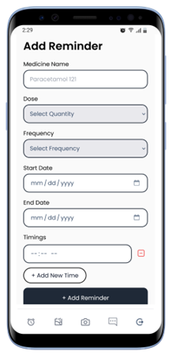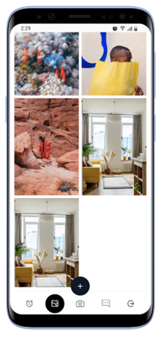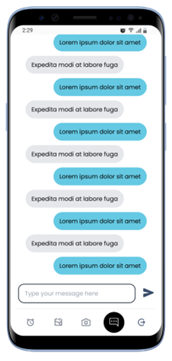

*Fig 5.1.4.5 Webapp Frontend - Reminder, Gallery, Chatbot*

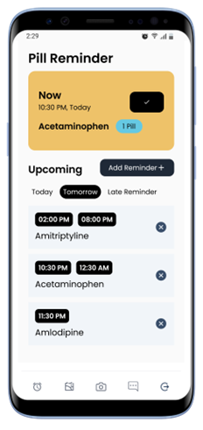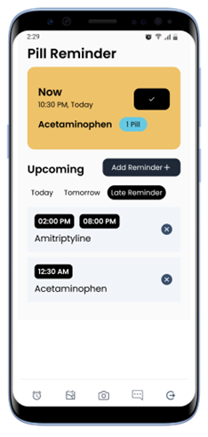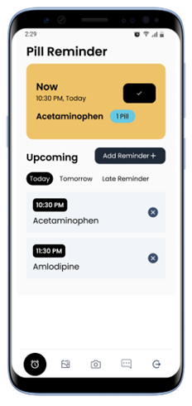

*Fig 5.1.4.4 Webapp Frontend - Reminder Setup*

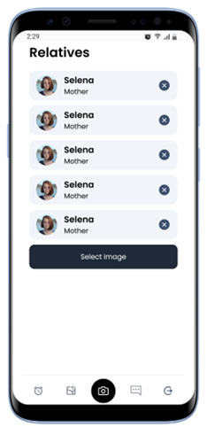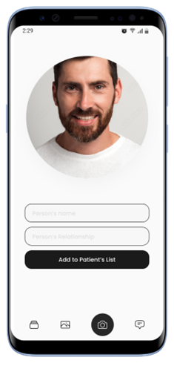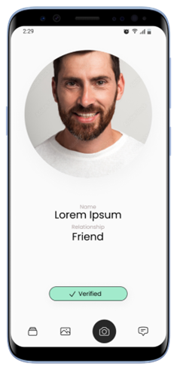

*Fig 5.1.4.4 Webapp Frontend - Face Recognition*

In conclusion, the Alzistant Web App, developed using React, aims to assist individuals with Alzheimer's disease in their daily activities. By providing a user-friendly interface and leveraging the power of React, the app offers features such as managing relatives' contact information, accessing a photo gallery, tracking medication schedules, and utilizing an interactive chatbot for assistance. The Sign Up/Login process is made seamless through "Login with Google," eliminating the need for tedious manual entry of personal details. With separate dashboards for patients and caretakers, the app caters to the specific needs of both groups, facilitating communication, organization, and support. Overall, the Alzistant Web App strives to enhance the quality of life for individuals with Alzheimer's, empowering them to navigate their daily lives more independently.

**5.1.6 Alzistant Mobile App (Frontend)**

# **Alzistant Mobile App**

Alzheimer's disease is a neurodegenerative condition that progressively impairs memory, thinking, and behavior. Alzheimer's patients frequently struggle with daily tasks like remembering appointments, taking care of their medications, and navigating unfamiliar environments as the disease worsens. For people with Alzheimer's, a mobile application can be a useful tool to help with these daily tasks. This article talks about creating a React Native app to help those with Alzheimer's.

**Purpose:**

This app's goal is to support people with Alzheimer's in their daily activities. The app aims to provide a user-friendly interface that helps individuals with Alzheimer's remember their relatives, take their medication on time, a chatbot to aid in case of any emergency, a photo gallery to help them keep all their memories with themselves and a login and register page to create and access their account.

**Dashboards:**

Two kinds are dashboards are provided one for the caretaker and the other for the patient:

1. **Patient’s Dashboard**

* Relatives
* Gallery
* Pill Tracker
* Chatbot

1. **Caretaker’s Dashboard**

* Relatives
* List of added Relatives
* Gallery
* Pill Tracker
* Add Pill Reminder
* Chatbot

**Features:**

The React Native app for Alzheimer's assistance includes the following features:

* **Pill Reminder System:** The app includes a pill reminder system that allows individuals to set reminders for all their medicines, medication schedules, etc. Also shows them the data of the upcoming pills and allows them to set if the pills were taken. This helps them to take their pills on time and fight the disease.
* **Medication Tracker:** The app provides a medication tracker that helps individuals keep track of their medication schedules. The tracker provides alerts and reminders to take medication on time.

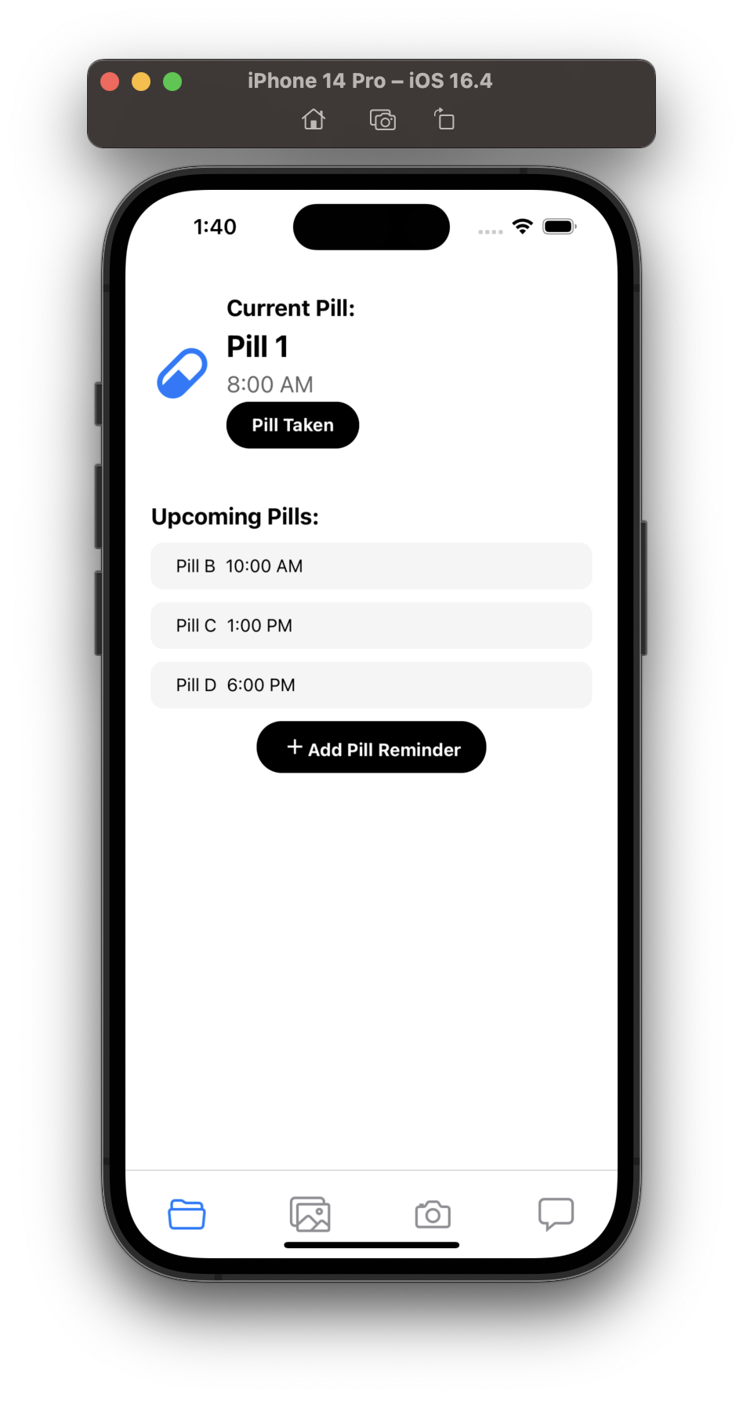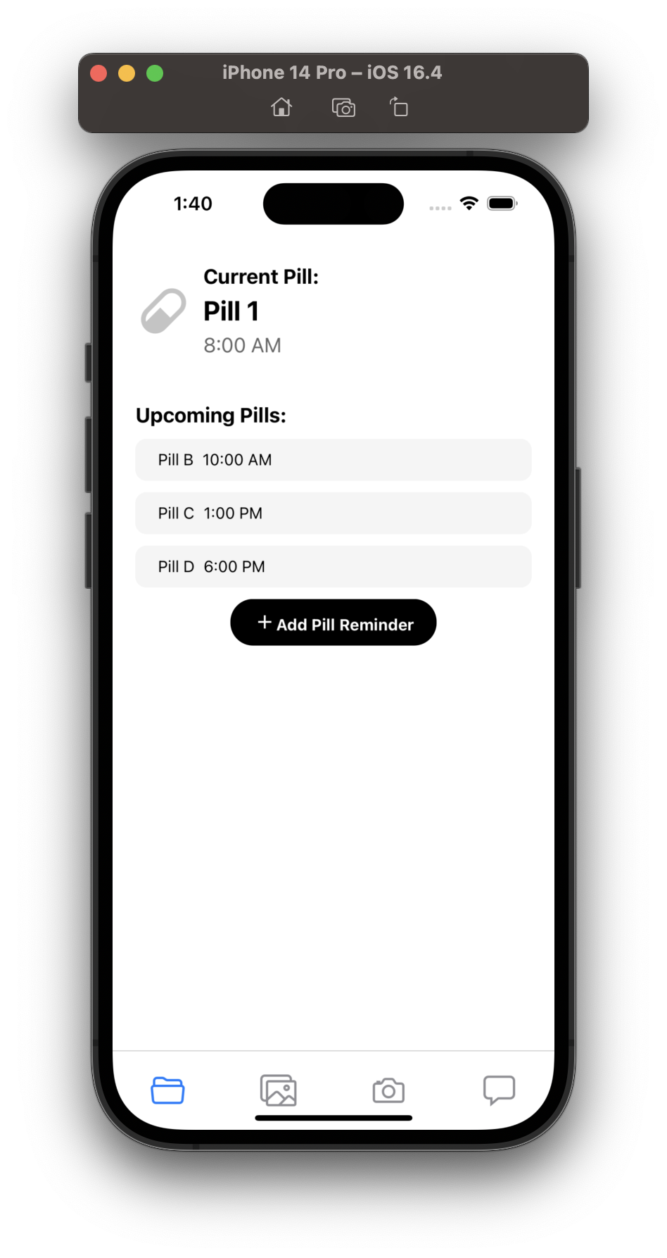

*Fig 5.1.5.1 Pill Reminder Working in App*

* **Photo Gallery:** This feature allows users to save photos of them and their loved ones, this would help them jog their memory. Here the patient/caretaker can add the pictures.

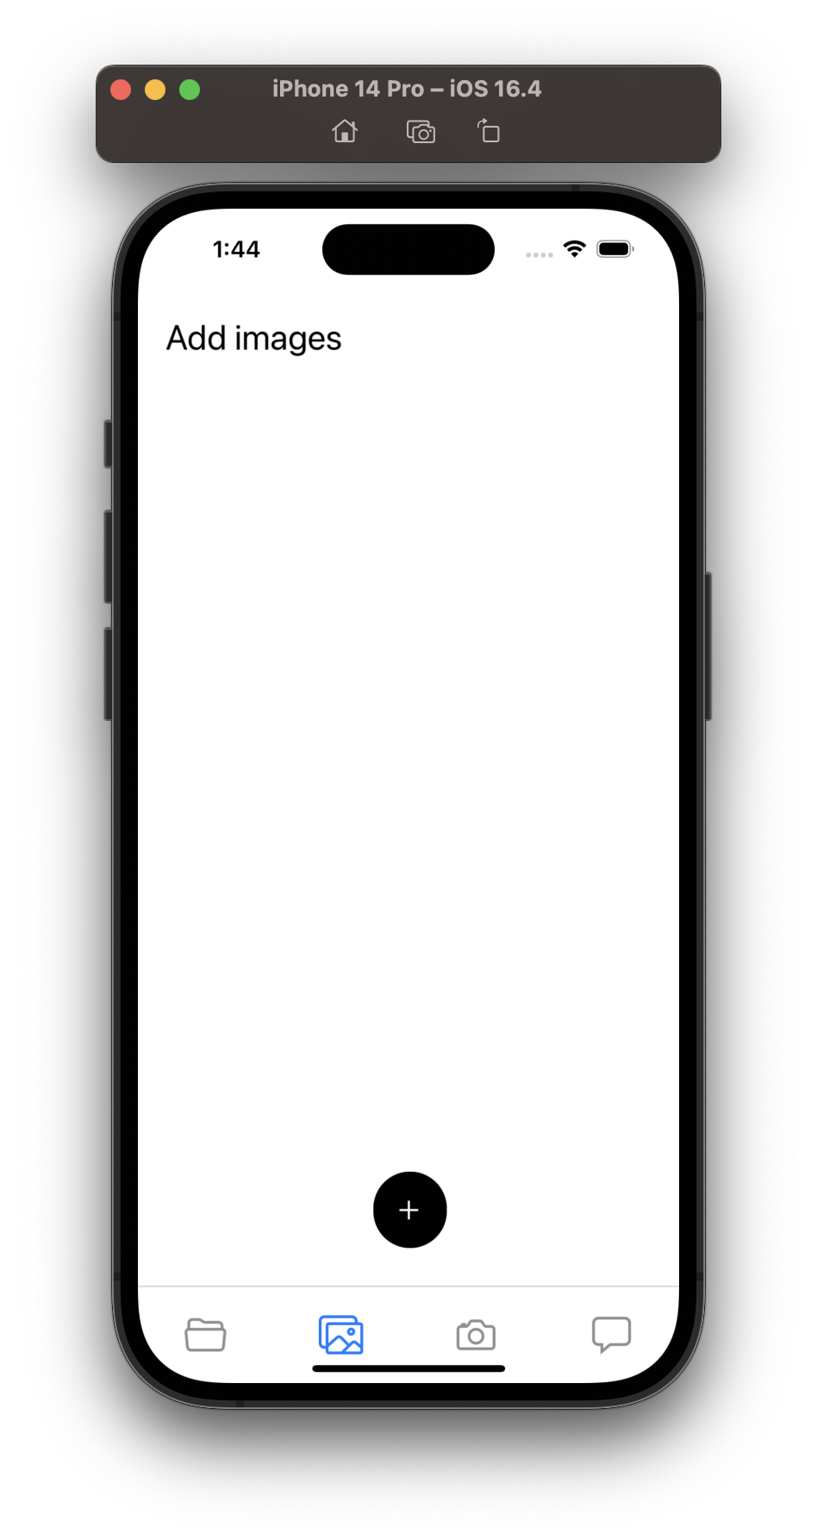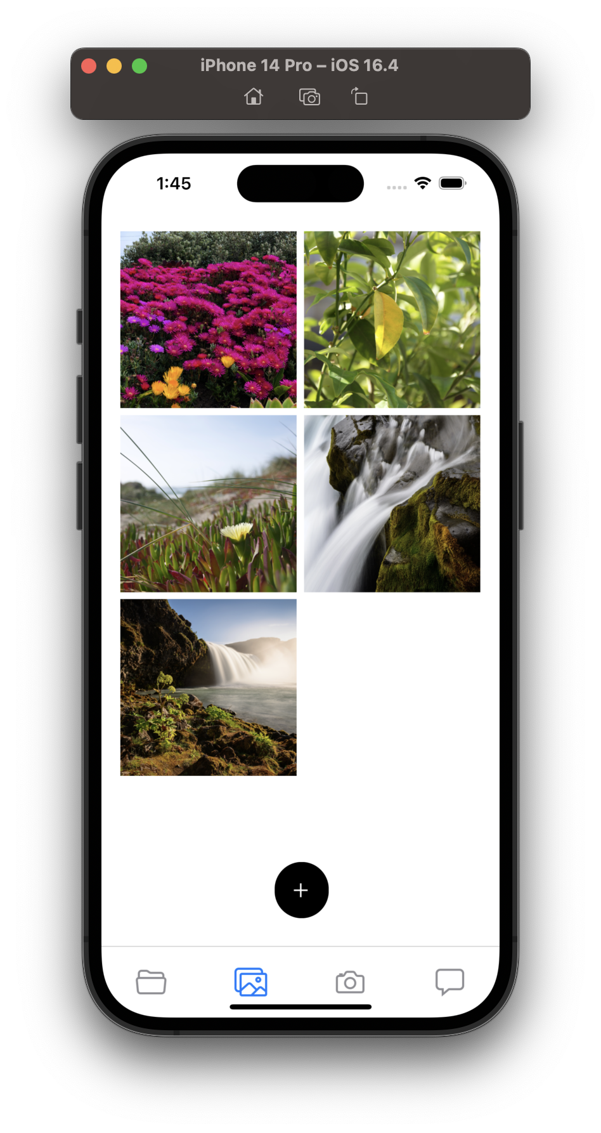

*Fig 5.1.5.2 Photo Gallery in App*

1. **Relatives List:** This is for the caretaker to add relatives and see all the relatives and people known to the patient are added and are legit.
2. **Add Relatives:** New relatives can be added also a new feature is planned to be added which will use face recognition and will allow patients to scan the face of people and it will return the relation the patient has with the person if any.

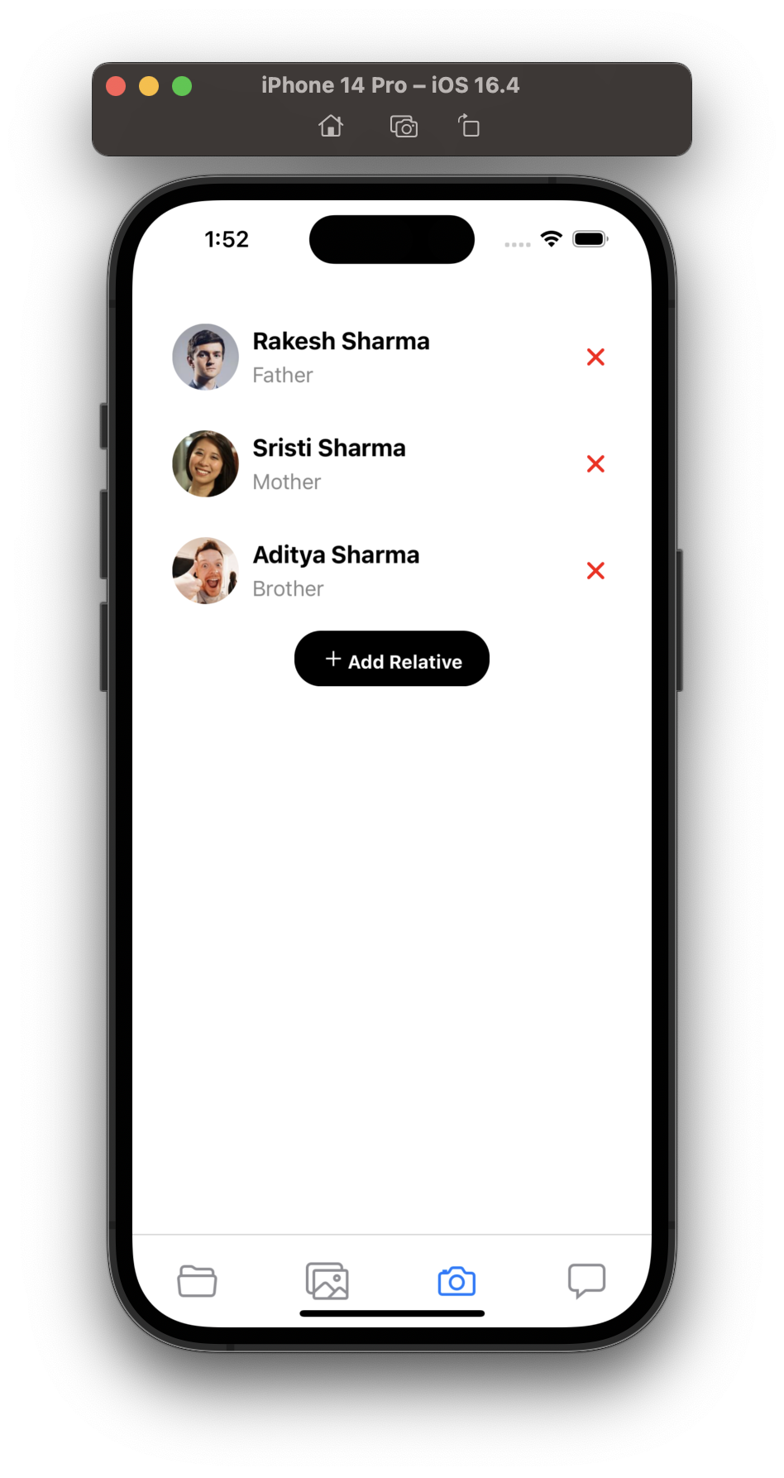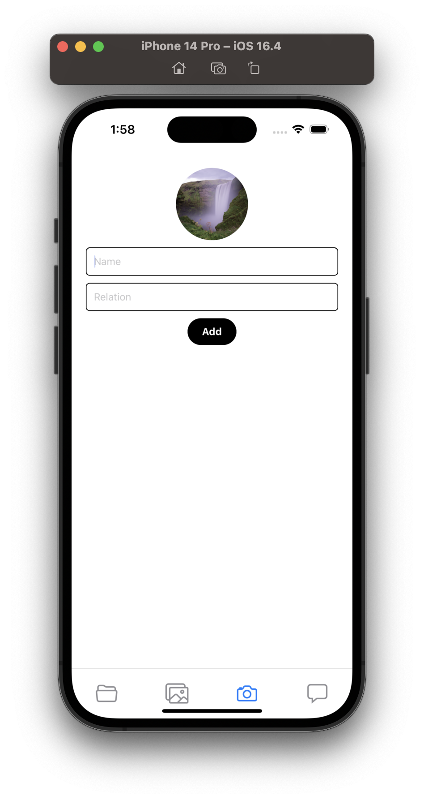

*Fig 5.1.5.3 Relatives List for Emergency Contact*

1. **Chat Bot**: The app provides this feature to let users interact with the caretakers and family members in case of any emergency or if they have any questions or concerns or get lost.

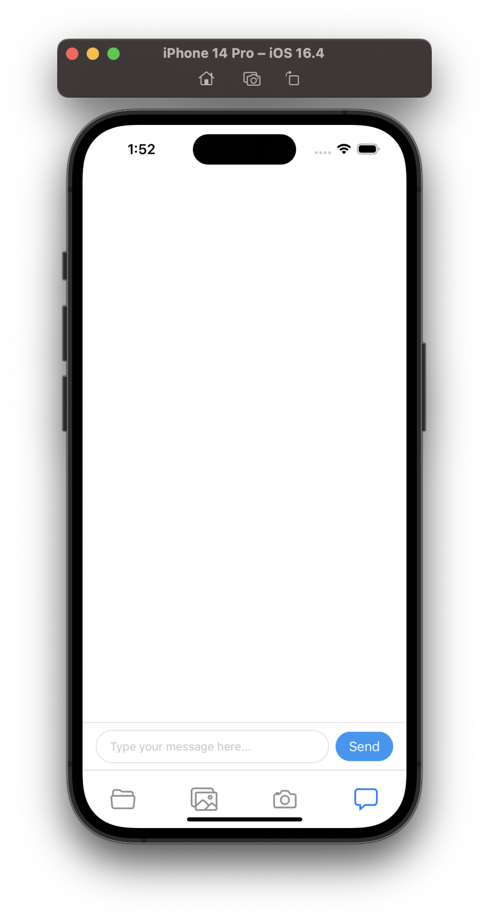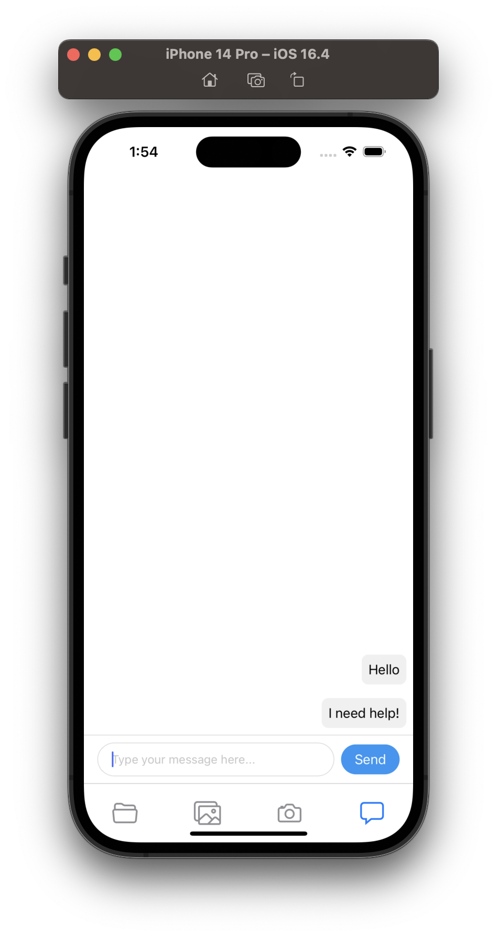

*Fig 5.1.5.4 Chatbot UI in App*

**Login and Signup pages:** To create and access their account.

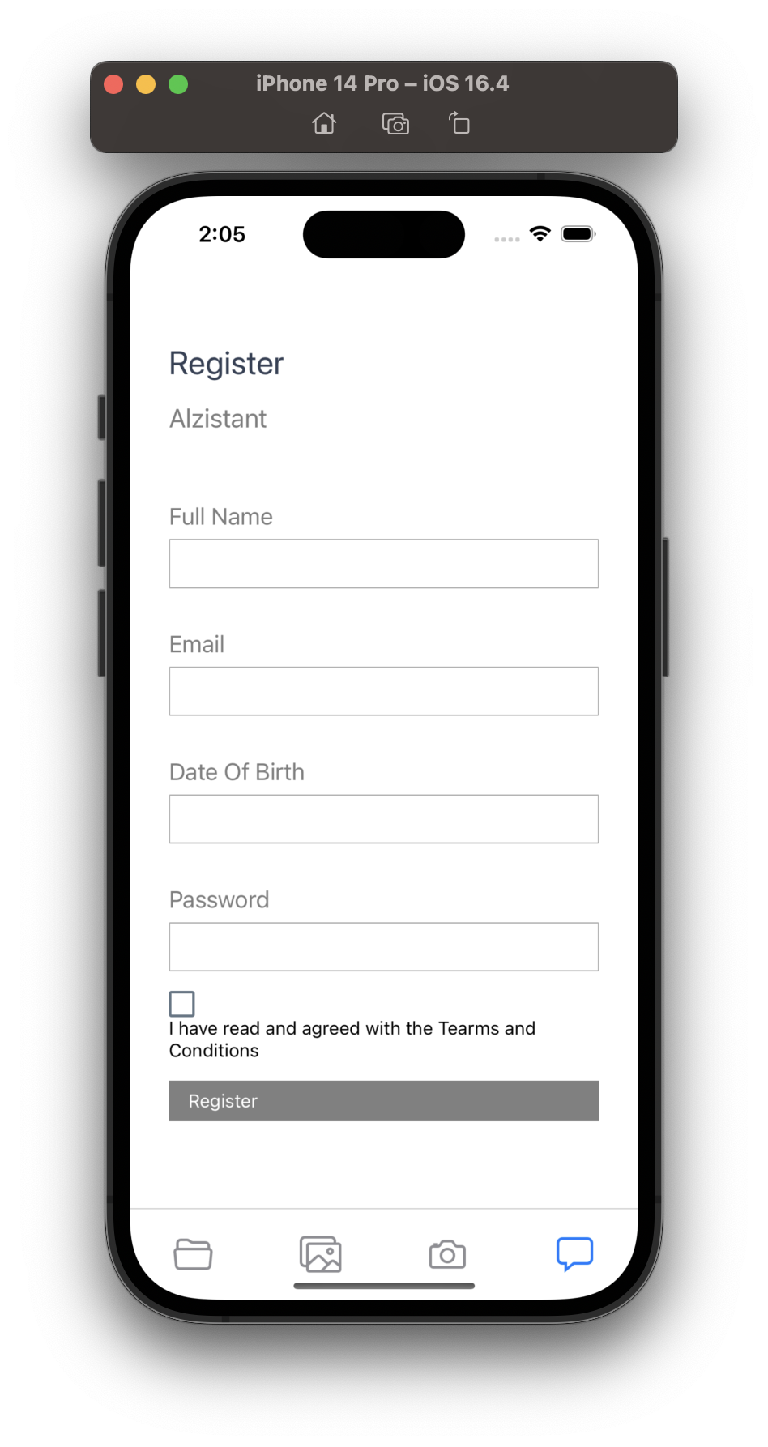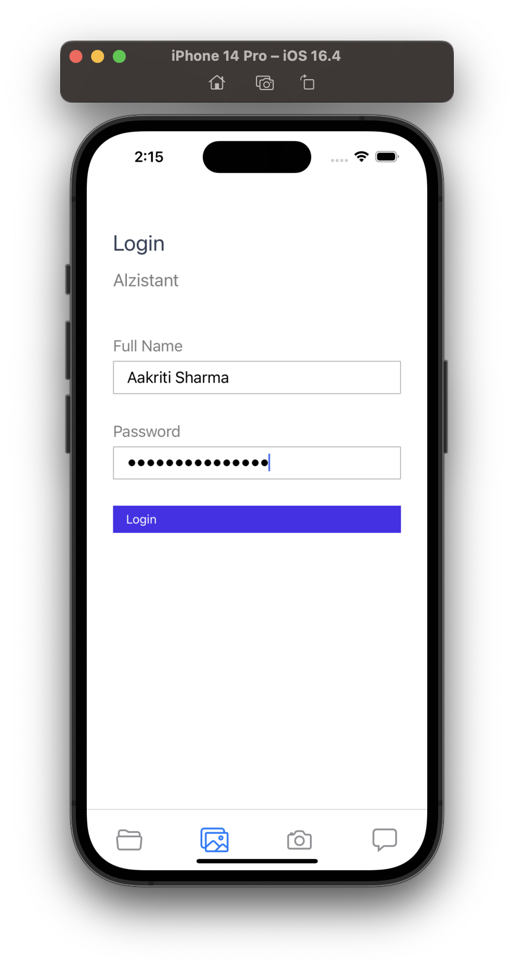

*Fig 5.1.5.5 Login Pages*

**Conclusion**

This documentation summarizes the UX analysis and anticipated features for a mobile application created with React Native. The application is made to offer assistance and support to elderly people who might need more care and attention from their caregivers. The application's features and capabilities have been thoughtfully created to guarantee simple navigation, clarity, and accessibility while also offering elderly people essential support to enhance their general health and wellbeing.

**CHAPTER 6**

**ANALYSIS AND RESULT**

**6.1 Analysis**

We performed a thorough analysis to evaluate the effectiveness and usability of our dementia patient assistant app while it was being developed and put into use. The app's features, user interface, and performance were all the focus of the analysis.

* **Feature Analysis**

We carefully considered each app’s feature's applicability to dementia patients' needs and its potential to enhance their quality of life. The features, which include face recognition, a pill-reminder system, a health bot, a task-reminder system, and cognitive games, were made to fully support dementia patients and address their unique challenges.

* **User Interface Evaluation**

The app's user interface underwent thorough testing to make sure dementia patients could use it easily and intuitively. We conducted usability testing with a variety of participants, including dementia patients, caregivers, and medical professionals, and we gathered their feedback. We improved the interface by analyzing user feedback, making it more user-friendly and suited to the requirements of dementia patients.

* **Performance Assessment**

In terms of responsiveness, stability, and resource usage, we evaluated the app's performance. To ensure compatibility and ideal performance, the application was tested across a range of hardware and operating systems. The analysis measured response times for various actions, measured memory usage, and assessed the app's capacity to handle multiple tasks at once. Any performance issues identified were addressed and optimized to deliver a smooth and efficient user experience.

**6.2 Results**

Our analysis' findings showed the dementia patient assistant app's beneficial effects and potency. Dementia patients' and their caregivers' lives were found to be significantly improved by the app's features and functionalities.

Key conclusions are as follows:

* **Improved Patient Independence**

Patients were able to quickly recognize and connect with their loved ones thanks to the face recognition feature, which encouraged familiarity and emotional well-being. The pill reminder system helped patients manage their medication schedules in an efficient manner, which improved medication adherence and overall health management. The cognitive games were entertaining and stimulating, which helped maintain cognitive abilities.

* **Enhanced Caregiver Support**

The caretaker interface of the app gave caregivers the necessary tools to effectively monitor and help the patients. Caretakers were able to promptly support patients and guarantee their safety and wellbeing thanks to access to patient location information, medication information, and task reminders. Caretakers were better able to provide patients with individualized advice and support thanks to the integration of a health bot.

* **Positive User Feedback**

User feedback collected during testing and evaluation highlighted the app's usability and effectiveness. Patients reported increased confidence, reduced anxiety, and improved daily routines with the app's assistance. Caregivers expressed satisfaction with the app's features, as it alleviated their caregiving responsibilities and facilitated better communication with the patients.

Overall, the analysis and results affirm the success of our dementia patient assistant app in providing comprehensive support to patients and caregivers. The app's features, usability, and performance contribute to an improved quality of life for individuals affected by dementia, addressing the unique challenges associated with the disease.

**CHAPTER 7**

**CONCLUSION AND FUTURE ENHANCEMENT**

**7.1 FUTURE SCOPE**

There is good scope to this project, and there are many unique features that can be added to it in the future.

* **Calming Sounds:** Certain sounds, such as nature sounds or which noise, can help calm and soothe dementia patients. Adding a library of calming sounds that can be played on demand may be helpful.
* **Picture and Video Library:** Including a library of familiar pictures and videos can help the patient recall important memories and people in their lives.
* **Voice Commands:** Adding voice commands can make the app more accessible for those with physical limitations or difficulty navigating a touchscreen device.
* **Virtual Reality:** VR can transport dementia patients to familiar places or experiences from their past, which can help improve their mood and cognitive function.
* **Family Communication:** Including a feature that allows family members and caretakers to easily communicate with each other can help ensure that everyone is on the same page regarding the patient’s care.
* **Emergency Alert:** An emergency alert feature that can quickly notify family members and caregivers of an emergency, such as a fall or medical issue, can be lifesaving.
* **Location Tracking**: Including location tracking can be helpful for patients who may wander off or get lost. The app can send alerts to caregivers if the patient strays too far from a designated area, such as their home or a care facility.
* **Integration with Wearable Technology:** Monitoring the patient's physical condition and activity levels is made easier by integrating the app with wearable technology, such as smartwatches or fitness trackers.
* **AI-powered Emotions Recognition and Analysis**: AI-powered recognition of emotions may assist the app recognize and respond to the patient's emotional state, providing appropriate support or guidance.
* **Medication Management**: Using the app in conjunction with medication management systems will ensure that patients take their medication on time, reducing the risk of adverse events or hospitalization.
* **Community and Volunteer Support:** Including a function that enables patients, caregivers, and to connect and support each other can create a sense of community and reduce social isolation for patients.

**REFERENCES**

[1] AWS Tutorial Available: [https://www.youtube.com/watch?v=rKNSc8RrwxA&list=PL6XT0grm_TfgtwtwUit305qS-HhDvb4du]

[2] Asana Available at [https://asana.com/]

[3] Mayo Clinic. "Dementia - Symptoms and causes." Mayo Clinic. Available at: [[https://www.mayoclinic.org/diseases-conditions/dementia/symptoms-causes/syc-20352013](https://www.mayoclinic.org/diseases-conditions/dementia/symptoms-causes/syc-20352013)]

[4] Open AI. "ChatGPT." Open AI Blog. Accessed [insert date]. Available at: [[https://openai.com/blog/chatgpt](https://openai.com/blog/chatgpt)]

[5] Wikipedia Available: [https://en.wikipedia.org/wiki/Agile_software_development]

[6] GitHub. Available: [https://github.com/teja156/amazon-rekognition-example/blob/main/lamdafunction.py]

